Two body data sheet (SI units only)
Plan view ▼
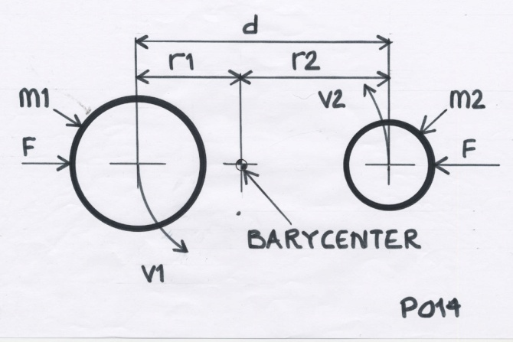

G = 6.674 E-11 a constant
M1 = mass, object 1 kg
M2 = mass, object 2 kg
d = centre to centre distance metres

Calculations :
r1 = M1 orbital radius = ( M2 / ( M1 + M2 ) ) * d metres
r2 = M2 orbital radius = ( M1 / ( M1 + M2 ) ) * d metres
F = ( G * M1 * M2 ) / d ² Newtons
g1 = M1 gravitational acceleration = F / M1 ( m / s ) / s
g2 = M2 gravitational acceleration = F / M2 ( m / s ) / s
v1 = M1 orbital velocity = sqrt ( g1 * r1 ) ( m / s )
v2 = M1 orbital velocity = sqrt ( g2 * r2 ) ( m / s )
t1 = M1 ( sidereal ) orbit time = ( 2 * π * r1 ) / v1 ( s )
t2 = M2 ( sidereal ) orbit time = ( 2 * π * r2 ) / v2 ( s )
( t1 and t2 will be the same )

NOTES :
- In stable orbit, momentum M1 = momentum M2
( M1 * v1 = M2 * v2 )

- If M1, M2 and t are known, find d from :
d = cube root ( ( t ² * G * M2 ) / ( 4 * π ² * ( M2 / ( M1 + M2 ) ) ) )

- If M1, M2 and d are known, find t(1) from :
t = sqrt ( ( 4 * π ² * ( M2 / ( M1 + M2 ) ) * d ³ ) / ( G * M2 ) )

- If M1, M2 and F are known, find d from :
d = sqrt ( ( G * M1 * M2 ) / F ) )

