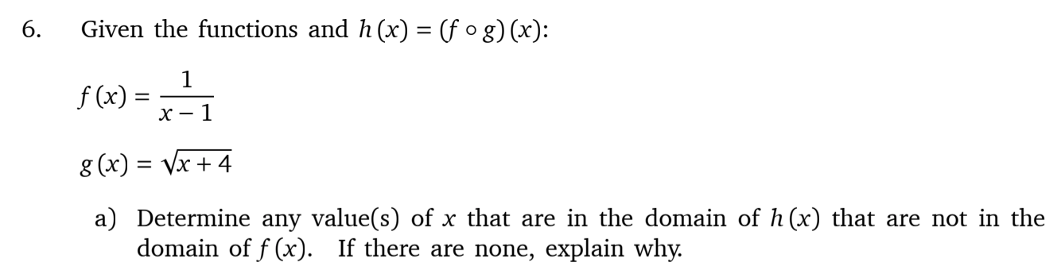

The domain of $h(x)$ is $\left[-4, -3\right)⋃\left(-3, ∞\right).$ The domain of $f(x)$ is $\left(-∞, 1\right)∪\left(1, ∞\right).$

$x=1$ is in the domain of $h(x)$ but not in the domain of $f\left(x\right).$

The domain of $h\left(x\right)$ is $\left[-4, -3\right)⋃\left(-3, ∞\right).$ The domain of $g\left(x\right)$ is $\left[-4, ∞\right).$

$x=-3$ is in the domain of $g(x)$but not in the domain of $h\left(x\right).$

