Part 1
Introduction
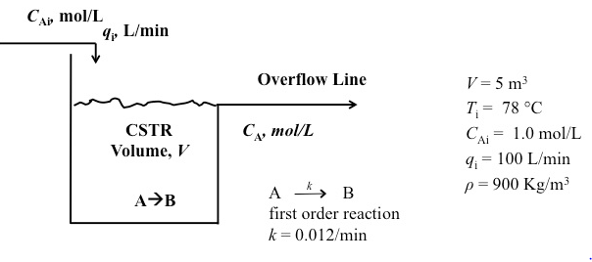

Assumptions:
- Perfectly mixed CSTR
- Mass densities of the feed and product streams are equal and constant
- Liquid volume is kept constant by an overflow line
- Reaction does not generate or take in heat (ΔH_{rxn}=0)
- Reaction occurs under isothermal conditions

Dynamic Model

In – out + generation = accumulation
First Order Reaction $${-r}_{A}=kc_{A}$$

$$V\frac{dc_{A}}{dt}=q\left(c_{Ai}-c_{A}\right)-Vkc_{A}$$

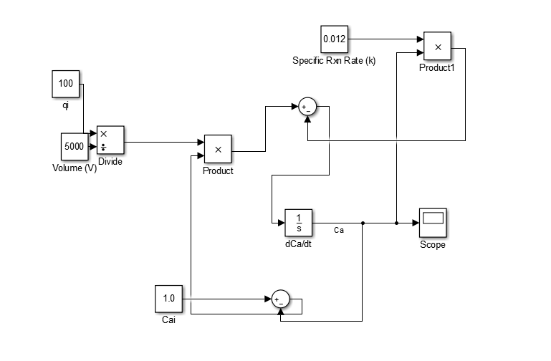
Figure 1: Simulink Process Model

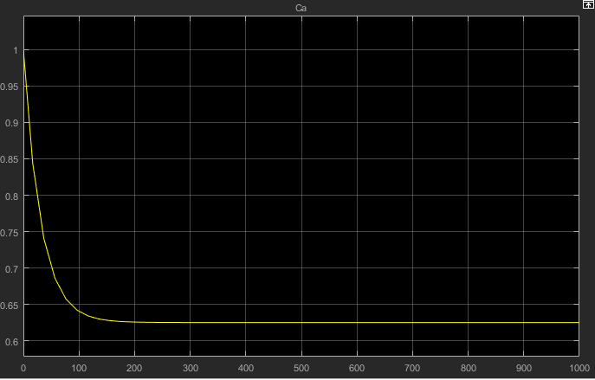
Figure 2: CSTR Composition vs. Time Behavior w/ initial conditions C_{Ai} = 1 M & q_{i}= 100 L/min
Manual Solution to Dynamic Relation

$$V\frac{dc_{A}}{dt}=q\left(c_{Ai}-c_{A}\right)-Vkc_{A}$$
At steady-state, $\frac{dc_{A}}{dt}=0$ $0=100\left(1-c_{A}\right)-0.012(5000)c_{A}$
$$100\left(1-c_{A}\right)=0.012(5000)c_{A}$$
$$100-100c_{A}=0.012(5000)c_{A}$$
$$100=100.06c_{A}$$
$c_{A}=0.625$ $\frac{mol}{L}$

Part 2

Controlled variable: $C_{A}$ (outlet concentration)
Manipulated variable: $q_{i}$ (feed flow rate)
Disturbance variable(s): $C_{Ai}$ (inlet concentration) & T_{i} (possibly)
Feedback Control Strategy: Measure $C_{A}$ and adjust q_{i}.

$c_{Ai}$ [mol/L]
C_{A}(t)
$$\tilde{C_{Asp}}$$
C_{Asp}
[mA]
[L/min]
[mA]
[mA]
q_{i}(t)
p(t)
e(t)
+
-
Control
Valve
Feedback
Controller
Stirred Tank
Analyzer
Calibration

C_{Am}(t)
C_{A}(t)
Analyzer (sensor) and transmitter
[mA]

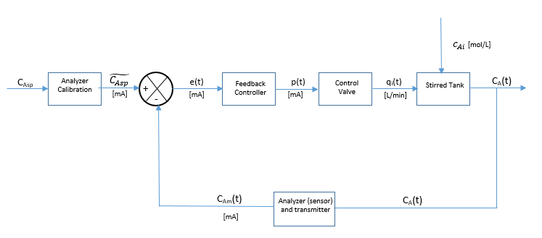
Figure 3: Feedback Control Strategy for CSTR system

Transfer Function Derivation
$$\frac{dc_{A}}{dt}=\frac{q}{V}\left(c_{Ai}-c_{A}\right)-kc_{A}$$

- Let $\frac{dc_{A}}{dt}=f(q,c_{Ai},c_{A})$
- Linearize.

$$V\frac{dc_{A}'}{dt}={{\left(\frac{∂f}{∂q}\right)}_{s}\left(q-\overline{q}\right)+\left(\frac{∂f}{∂c_{Ai}}\right)}_{s}\left(c_{Ai}-\overline{c_{Ai}}\right)+{\left(\frac{∂f}{∂c_{A}}\right)}_{s}\left(c_{A}-\overline{c_{A}}\right)$$

${\left(\frac{∂f}{∂q}\right)}_{s}=\overline{c_{Ai}}-\overline{c_{A}}$ ${\left(\frac{∂f}{∂q}\right)}_{s}=\overline{q}$ ${\left(\frac{∂f}{∂c_{A}}\right)}_{s}=-\overline{q}-Vk$

$$V\frac{dc_{A}'}{dt}=\left(\overline{c_{Ai}}-\overline{c_{A}}\right)q^{'}+\overline{q}c_{Ai}^{'}+\left(-\overline{q}-Vk\right)c_{A}^{'}$$

$$VsC_{A}^{'}\left(s\right)=\overline{c_{Ai}}Q^{'}\left(s\right)-\overline{c_{A}}Q^{'}\left(s\right)+\overline{q}C_{Ai}^{'}\left(s\right)+\left(-\overline{q}-Vk\right)C_{A}^{'}(s)$$
$$VsC_{A}^{'}\left(s\right)-\left(-\overline{q}-Vk\right)C_{A}^{'}(s)=\overline{c_{Ai}}Q^{'}\left(s\right)-\overline{c_{A}}Q^{'}\left(s\right)+\overline{q}C_{Ai}^{'}\left(s\right)$$

Nomenclature

