QUESTION
I’m trying to solve the following PDE using OCFEM using 2nd order Legendre polynomial in three elements.
@x=0
@x=1
ICS:

COLLOCATION POINTS
- Legendre polynomial was shifted in the interval [0,1/3], [1/3,2/3], and [2/3,1] and the roots of the 2nd order Legendre polynomial in the respective interval.
- Accordingly the collocation points are:
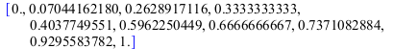

FIRST ELEMENT EQUATION
- For the first element the following equation is obtained:
- With unknowns A1₀, A1₁, and A1₂.
- Substituting in the PDE we get for the first element:
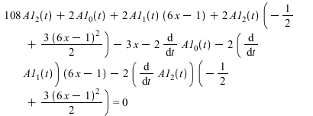

SECOND ELEMENT EQUATION
- For the second element the following equation is obtained:
- With unknowns A2₀, A2₁, and A2₂
- Substituting in the PDE we get for the second element:
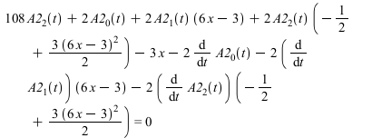

THIRD ELEMENT EQUATION
For the third element the following equation is obtained:
With unknowns A3₀, A3₁, and A3₂
Substituting in the PDE we get for the third element:
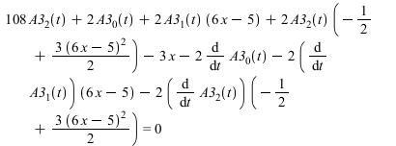

EQUATIONS FOR EACH COLLOCATION POINT
LEFT-MOST BOUNDARY CONDITION (x=0)
For left-most boundary condition, substituting x=0, and the first element equation in the first boundary condition result in:

INTERIOR POINTS FIRST ELEMENT
For the interior points in the first element (x=~0.07 and ~0.262) we substitute those x values in the first element PDE equation and we get the following two equations:
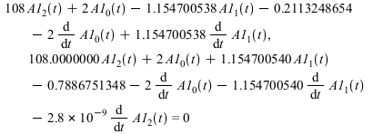
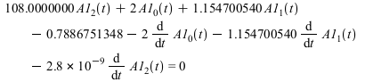
CONTINUITY BETWEEN ELEMENT 1 AND 2
The continuity between element 1 and 2 equation we get it by equating first element equation and second element equation and substituting x=1/3.

INTERIOR POINTS SECOND ELEMENT
Similarly, for the interior points in the second element (x=~0.4 and ~0.6) we substitute those x values in the second element equation and we get the following two equations:
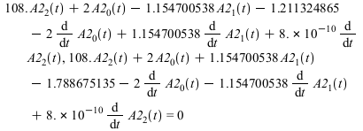
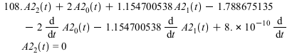
CONTINUITY BETWEEN ELEMENT 2 AND 3
The continuity between element 2 and 3 equation we get it by equating second element equation and third element equation and substituting x=2/3.

INTERIOR POINTS THIRD ELEMENT
Similarly, for the interior points in the third element (x=~0.7 and ~0.9) we substitute those x values in the third element equation and we get the following two equations:
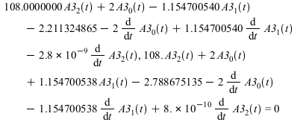
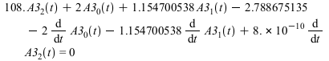

RIGHT-MOST BOUNDARY CONDITION (x=1)
For right-most boundary condition, substituting x=1, and the first element equation in the second boundary condition result in:

INITIAL CONDITIONS
For initial conditions,
We substitute (x=~0.07,~0.262, and 1/3) in the first element equation and we get
We substitute(x=~0.4,~0.6, and 2/3) in the second element equation and we get
We substitute(x=2/3, ~0.7, and ~0.9) in the third element equation and we get

SUMMARY
In total we have
- 6 interior point
- 2 continuity equations
- 2 boundary conditions
- Total: 10 equations
Unknowns:
- A1₀, A1₁, and A1₂
- A2₀, A2₁, and A2₂
- A3₀, A3₁, and A3₂
- Total: 9 unknowns

