This virtual lab is an introduction to a topic rather than an application of something that we have learned.
We need to introduce a new concept called Torque (τ). Torque works in a way similar to forces. The difference is that when we are talking about rotation, we are interested in both the size of the force and where that force acts. We always define a point around which our object is going to pivot. The torque is the magnitude of the force (F) multiplied by the lever arm ($l$). The lever arm (which we will talk more about in class) is the distance from the pivot point to where the force acts on an object. The units of torque are Nm. Torque is a vector quantity. The direction for Torque is clockwise (-) or counter-clockwise (+).
Torque $τ=F x l$
•Torque = Force x lever arm
•(Magnitude of the force perpendicular to the lever arm) x (Distance from pivot point)
Direction: The torque is positive for counter-clockwise motion, negative for clockwise motion.
SI Unit of Torque: newton x meter (N·m)
Answer the following questions about the direction that the stick will rotate in each case.
Please use WORD formatting options to circle, bold, highlight, or color the fonts to make your final answers readily visible to each of the situations included below. Treat each of the following ten examples/diagrams of meter stick on fulcrum with attached masses as ten independent equilibrium/no equilibrium situations. Provide both the final decision (if it is equilibrium for rotation – out of the total net torque equal to zero, or rotation with specified direction of rotation due to a net torque different than zero. On the second page, please provide both word description of the solution and the detailed math that goes with it for each of these ten diagrams. Let’s proceed.
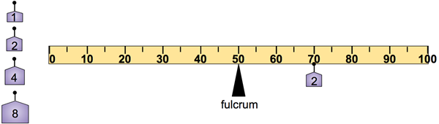  clockwise counterclockwise no rotation | 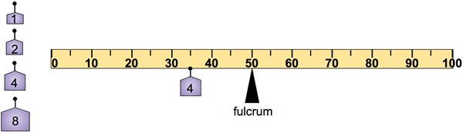  clockwise counterclockwise no rotation
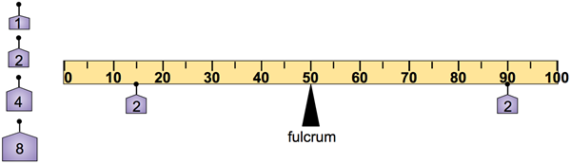clockwise counterclockwise no rotation | 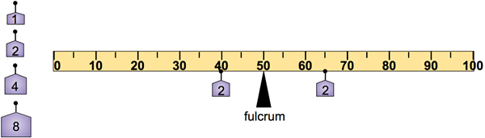clockwise counterclockwise no rotation
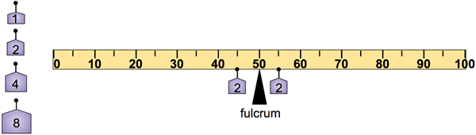clockwise counterclockwise no rotation | 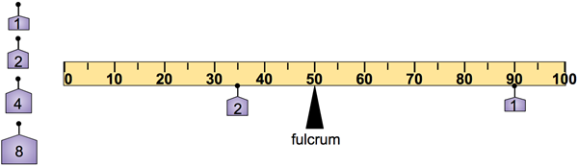  clockwise counterclockwise no rotation
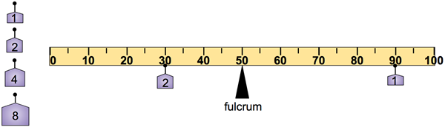clockwise counterclockwise no rotation | 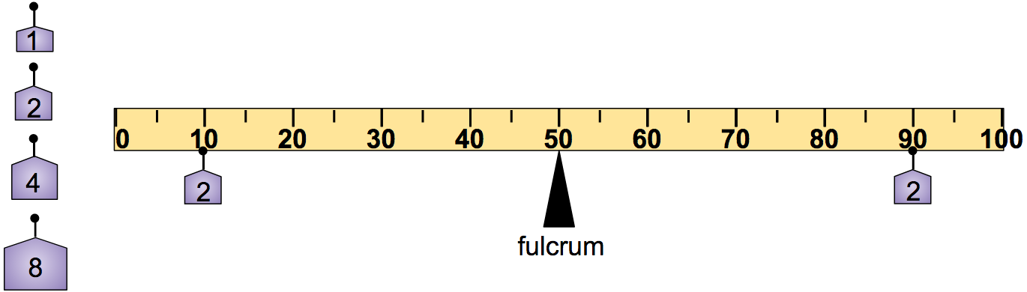clockwise counterclockwise no rotation
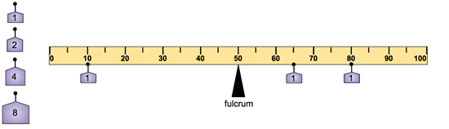clockwise counterclockwise no rotation | 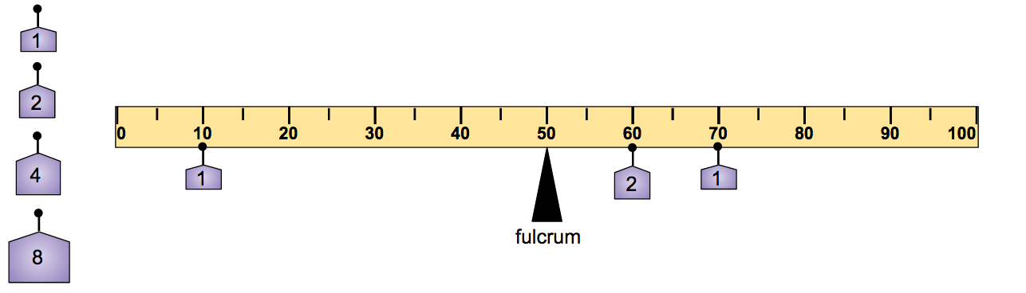clockwise counterclockwise no rotation

ONE SAMPLE (Already Solved) Problem Follows Below
Please use it as a practice problem and then, solve on your own the three exercises on the last page. These three last exercises are independent from the prior ten diagrams that gradually increased the difficulty level of your decision on the rotational motion, or the state of equilibrium. Please save everything in Word file format with your name to identify the work and submit all of your detailed work of this Word document via Canvas assignment for me to grade it.
To determine whether the stick is in equilibrium or will rotate, you can use Newton’s 2nd Law for torques. It goes like this: $Στ=0$.
I can then write down all the torques on the object making sure that the clockwise torques are negative and the counterclockwise torques are positive.
The other way that I can set this up is to note that if the Net Torque is zero, then the torques rotating the stick clockwise must be equal to the torques rotating the stick counter-clockwise or: $τ_{cw}=τ_{ccw}$
I’ll show you what I mean. Consider the case on the next page. All the forces are weights (F=mg=(1kg)(9.8^{m}/s²) = 9.8 N) and the pivot point is at the fulcrum of the meterstick.
First, I will draw a Free Body Diagram. When I draw the FBD, I will also put in the distances to the forces from the fulcrum (lever arm).
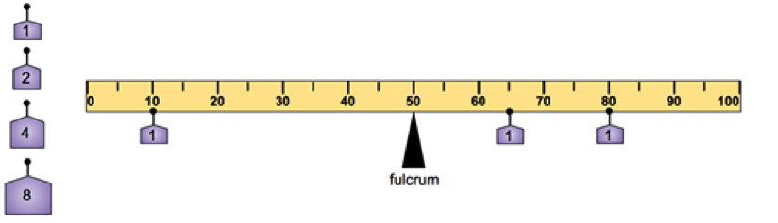
.40 m
.30 m
.15 m
9.8N
9.8N
9.8N

I am going to use Newton’s 2nd Law for torques to add up all of the torques. The weights on the right side will cause the stick to move clockwise, so they will be negative.
The ones on the left cause the stick to rotate counterclockwise and will be positive: $Στ=\left(9.8N\right).40m-\left(9.8N\right).15m-9.8N\left(.30m\right)=-0.49Nm$.
This stick is NOT in equilibrium. It will rotate clockwise since there is extra torque on that side.
Now, where should I put a 1kg mass so that the meterstick is in equilibrium? I need to add the mass so that it puts a +0.49 Nm torque on the stick. A 1kg mass will have a force of 9.8N. To get a torque of 0.49 Nm, I need the lever arm to be 0.05m. To make the torque positive, this mass should be placed at the 5 cm from the fulcrum at the 45cm position on the stick.

9.8N
9.8N
9.8N
9.8N

Let’s do a check: : $Στ=\left(9.8N\right).40m-\left(9.8N\right).15m-9.8N\left(.30m\right)+9.8N(0.05m)=0$.
Also: $τ_{cw}=τ_{ccw}$
$$9.8N\left(0.30m\right)+9.8N\left(0.15m\right)=9.8N\left(0.05m\right)+9.8N(.40m)$$
$$9.8N\left(0.45m\right)=9.8N(.45m)$$

Both methods check out. I know that this seems a bit much right now, but these problems will get more complicated and it is good to get in good habits now.

YOUR TURN NOW:
For the following three situations, where should I put a 1kg mass so that the stick is balanced?
Problem 1)

Write here your answer and the detailed math that goes with it.
Problem 2) For the following situation, where should I put a 1kg mass (aside from the already placed ones) so that the stick is balanced?
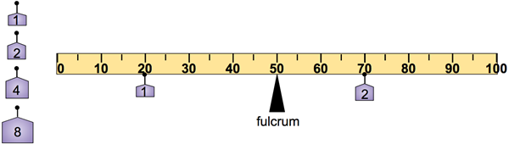

Write here your answer and the detailed math that goes with it.

Problem 3) In this situation, where should I put a 2kg mass so that the stick does not rotate?

Write here your answer and the detailed math that goes with it.

