Addition of forces aimed at an angle

Object:
Add and subtract parallel and non-parallel vectors;

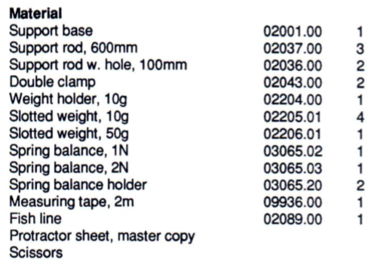
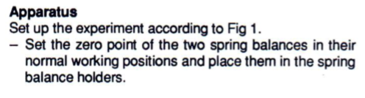
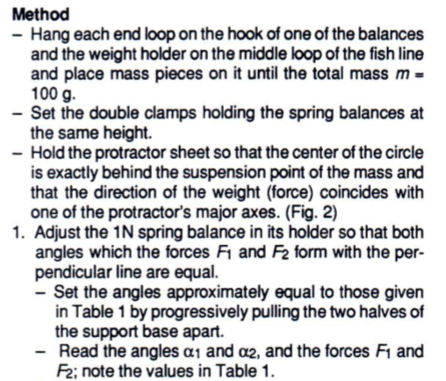
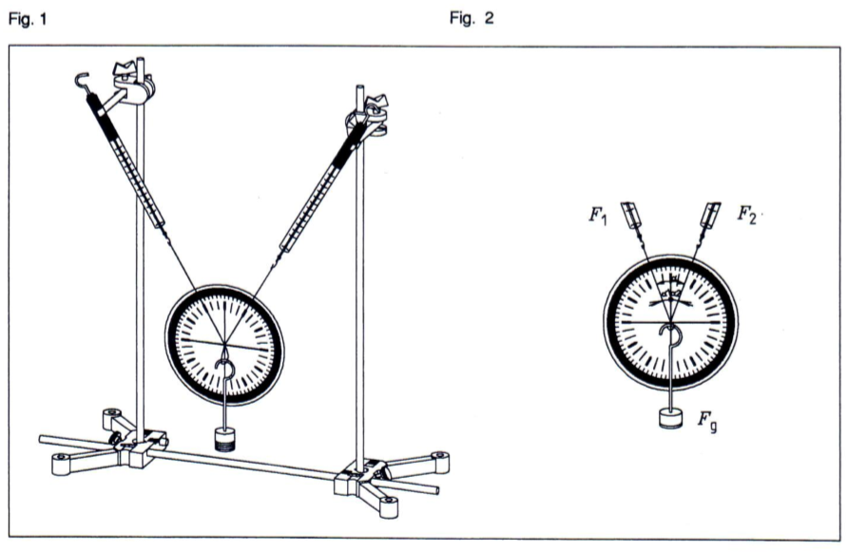
Results
M = 100 g; F_{g} = 1 N
Table 1
α₁/ ° | α₂/ ° | α/ ° | F₁ /N | F₂ /N | F_{r} /N
20 | 20 |  | 0.55 | 0.50
30 | 30 |  | 0.59 | 0.58
40 | 40 |  | 0.62 | 0.63
50 | 50 |  | 0.74 | 0.76

Table 2
α₁/ ° | α₂/ ° | α/ ° | F₁ /N | F₂ /N | F_{r} /N
40 | 25 |  | 0.46 | 0.70
55 | 20 |  | 0.33 | 0.85
70 | 18 |  | 0.25 | 0.94
90 | 15 |  | 0.24 | 1.04
115 | 18 |  | 0.40 | 1.22

Evaluation
- Calculate α from α₁ and α₂ and complete the two tables.
- Using the measured values in the tables, draw 2 force parallelograms each on a separate sheet of paper. Use a specific scale for the force,
e.g. 1 N = 10 cm
- Determine the resultant force F_{r} from the diagrams graphically and record the values in the tables.
- Compare the graphically determined values for the resultant force F_{r} with the weight (force) F_{g}. What do you observe?
………………………………………………………………………………………………………………………………………………………………………………………………………………………………………………

- Formulate the result of the experiment:
……………………………………………………………………………………………………………………………………………………………………………………………………………………………………………………………………………………………………………………………….

- Describe how you determined the resultant F_{r}:
………………………………………………………………………………………………………………………………………………………………………………………………………………………………………………………………………………………………………………………………
Supplementary problem
- Calculate the resultant force F_{rb} for several measurements using
$$F_{rb}=\sqrt{F_{1}^{2}+F_{2}^{2}+2F_{1}F_{2}\cos{α}}$$
and compare the values obtained with the weight (force) F_{g} and the values F_{r} for the resultant force which were determined from the diagrams:

$F_{rb}$ = ……………………………….

