Assumptions
- Casing is incompletely cemented
  - For the purpose of this discussion, 25% of the annular area is void of cement
- Other data
  - Fracturing pressure: 5300 psi
  - Pore pressure: 1700 psi
  - Casing OD: 4.5 inches
  - Casing Yield: 307000 lbf

Discussion

Figure 1 contains the starting point for the frac with the assumptions from the previous section. A void in the cement at the top of the pipe leaves 25% of the annular are cement free. Under this scenario, the forces acting on the pipe before starting the frac will be balanced.
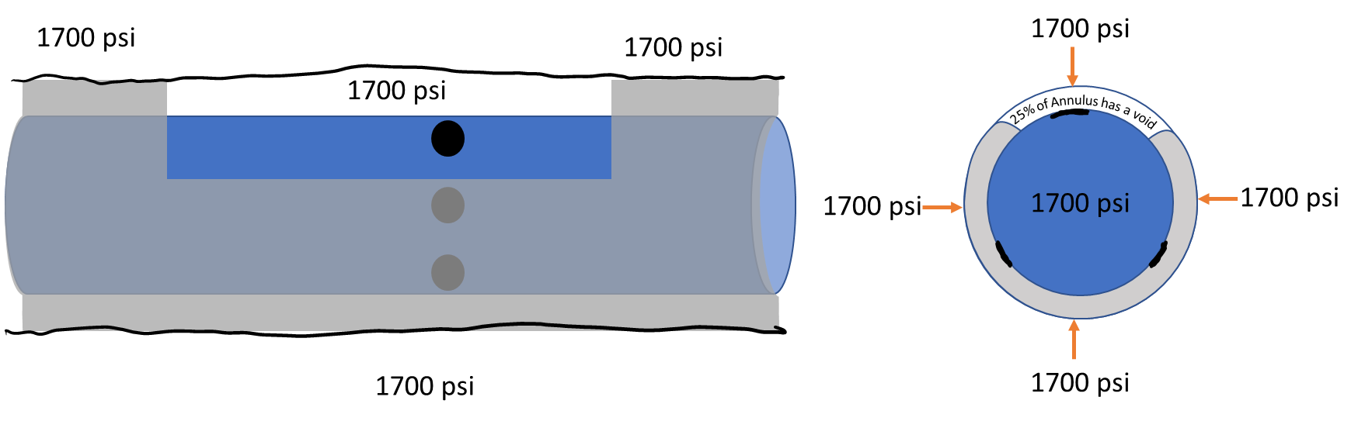
Figure 1: Starting point of frac
Once fracturing is attempted, the pressure will increase in the void but, until the fracture is initiated, the rest of the outer pipe will not see the pressure. This will cause an imbalance in forces acting on the outside of the pipe.

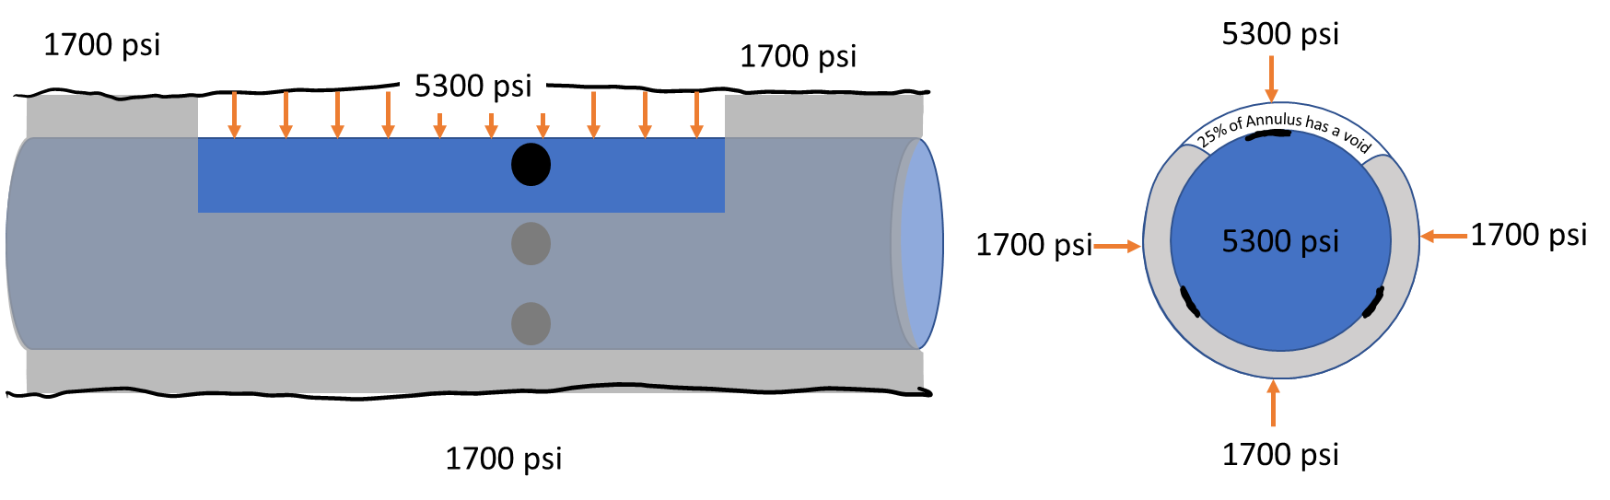
Figure 2: Force Imbalance at start of frac

The force imbalance per inch of pipe can be calculated using the area of the pipe open to the frac pressure.

$$Force Imbalance per inch= \left(P_{frac}-P_{res}\right)\frac{Area{ \left(in\right)}^{2}}{in}$$
$$\frac{Area{ \left(in\right)}^{2}}{in}=π×diameter×length×\%void=3.1418×4.5 in×1in×0.25=3.53 {{in}^{2}}/{in}$$
$$Force Imbalance per inch= \left(5300 psi-1700 psi\right)\frac{3.53{ \left(in\right)}^{2}}{in}=12700 \frac{{lb}_{f}}{in}$$

Assuming the yield strength of the pipe is 307000 lbf, the length required to have enough force to yield the pipe would be:
$$Void Length to yield pipe= \frac{307000 {lb}_{f}}{12700 {{lb}_{f}}/{in}}=\sim 24 in or 2 feet$$

