*P837: Friend to iostream class for overloading extraction and insertion:
*see program 14.11: left argument is ostream or istream ref object, right is ref FeetInches object.
*For insertion operator: friend ostream &operator<<(ostream & strm, const FeetInches4 &obj)
{ strm << obj.feet << “ft “ << obj.inches << “in\n\n”; return strm;}}
*For extraction operator: friend istream &operator>>( (istream & strm, const FeetInches4 &obj)
{ strm >> obj.feet; strm >> obj.inches;} return strm; }
*In main(){FeetInches distance; cout << distance; or cin >> distance;}
*P814: Memberwise Assignment: member data of Objects of the same Class may be assigned to one
another using = operator. Problem is if one of the variable is a pointer to NEW memory, then the
address of the NEW memory will be the same for both object. See p816. Constructor:
PersonInfo(char*n, int a){name = new char[strlen(n) + 1]; strncpy(…); age = a;} , address name
is copy over. Need to use Copy Constructor:
Copy Constructor
*P816:Be careful using Constructor in class with pointers as it’s SHALLOW COPY. See detail on Constructor
in cht 13. See Rule of Three: https://en.wikipedia.org/wiki/Rule_of_three_(C%2B%2B_programming)
*P818:Copy Constructor solves the problem as it can copy the pointers but different addresses:
PersonInfo(const PersonInfo &obj) {name = new char[strlen(n) + 1];
Strncpy_s(name, (strlen(obj.name)+1), obj.name, (strlen(obj.name)+1)) ; age = a;}
*Using &obj in argument reference to object save a copy. Use const to avoid changing, compiler will
give error without it.
*See below, PersonInfo clone = bob; where left side “clone” is object of PersonInfo, and the right size of
= is bob also object of PersonInfo, compiler will use the Copy Constructor to initiate clone.
*Fig.8 is program Copy Constructor in chapter 14. below shows name initialize for bob is different from clone.
* classname (const classname &obj){..}. Below, line10 is Copy Constructor. Argument is passed by reference.
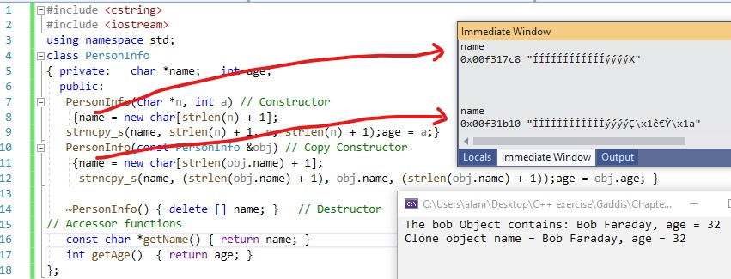

#include <iostream> #include <cstring> #include "PersonInfo.h" using namespace std;
int main(){ char bobC[] = "Bob Faraday"; char cloneT[] = "clone";
PersonInfo bob(bobC, 32); PersonInfo clone(cloneT, 44); clone = bob;//copy constructor
cout << " The bob Object contains: " << bob.getName() << ", age = " << bob.getAge() << endl;
cout << " Clone object name = " << clone.getName() <<", age = " << clone.getAge() << "\n\n"; return 0; }
*See program Alan version Jtbell in cpt14: using c-string rather then name=new char[]: const int size = 25;

