Efficiency of a reversible engine
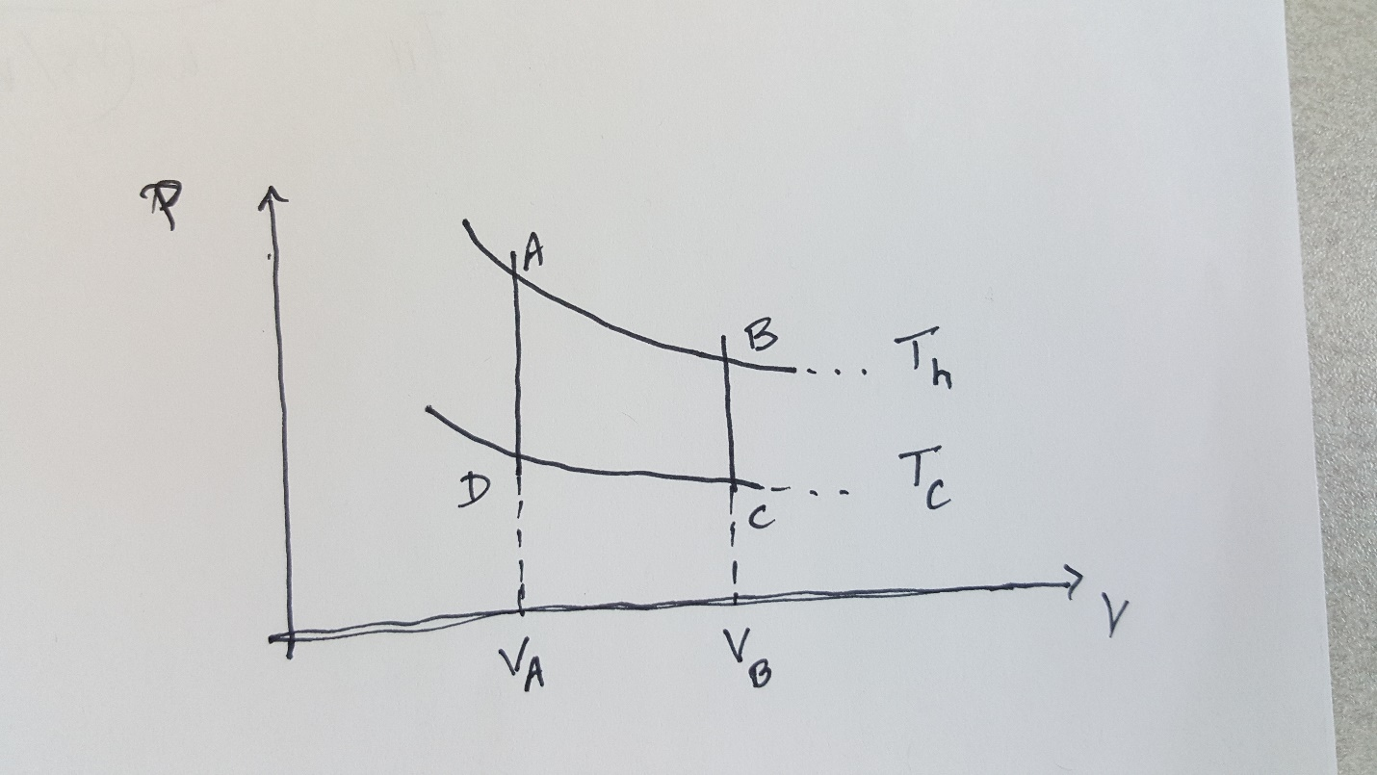

The process ABCDA, shown in the figure above, is bounded by two isotherms at T_{h} and T_{c}, and by two isochores, at V_{A} = V_{D} and V_{B} = V_{C}.
We are writing the first law of thermodynamics as:
$$Q=∆U+W$$
W is the work done by the system, which is one mole of ideal gas.
A B (Isothermal process):
$$W=RT_{h}ln\left({V_{B}}/{V_{A}}\right)>0 (2)$$
$$∆U=0$$
$$Q_{h}=W (3)$$

B C (Isochoric process):
$$W=0$$
$$Q= C_{v}\left(T_{c}-T_{h}\right)<0 (4)$$
$$∆U=Q$$
C D (Isothermal):
$$W=RT_{c}ln\left({V_{D}}/{V_{C}}\right)<0 (5)$$
$$∆U=0$$
$$Q_{c}=W (6)$$
D A (Isochoric):
$$W=0$$
$$Q= C_{v}\left(T_{h}-T_{c}\right)<0 (7)$$
$$∆U=Q$$

For the total cycle:
Change in internal energy:
The changes in internal energy during the two isochoric processes cancel out, so the net change in internal energy is zero, as expected.
Net work done:
$$W_{net}= W_{A→B}+W_{C→D}$$
Heat Exchange:
Net heat exchanged during the two isochoric processes is zero, from (4) and (7).
That leaves
$$Q_{net}=Q_{h}+Q_{c}=W_{net}$$
This is as required by the first law of thermodynamics
Efficiency:
$$ε=\frac{W_{net}}{Q_{h}}=\frac{RT_{h}ln\left({V_{B}}/{V_{A}}\right)+RT_{c}ln\left({V_{D}}/{V_{C}}\right)}{RT_{h}ln\left({V_{B}}/{V_{A}}\right)}=1-\frac{T_{c}}{T_{h}}$$
Exactly that of a Carnot engine.

