*Example of Overload Constructor: exercise 13.12 with explanation: The program is stepped through one
line at a time. The number with RED underscores are the steps of execution. Follow the number step
by step to see how the program flow and jump between invItem and main().
This is invItem.h file. Pay attention to Immediate Window the address of description, cost and units.
Same names for all 3 Constructors but different address, this is overload.
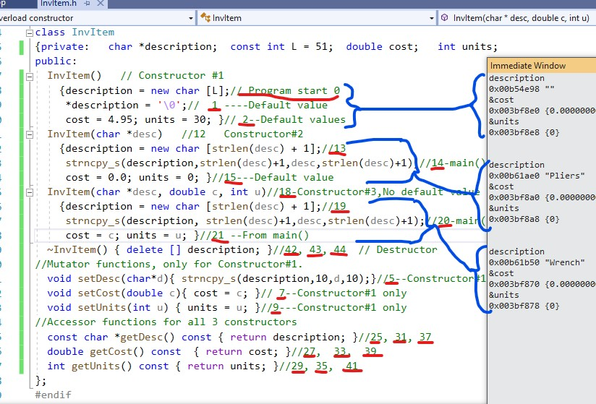
This is the main(): Follow the step number back and fore to invItem.h and back.


