Thermal Conductivity of Building Materials

Purpose
The purpose of this laboratory activity is to determine the thermal conductivity of some common building materials. The rate of thermal conduction through five building materials will be determine using the thermal conductivity setup shown below

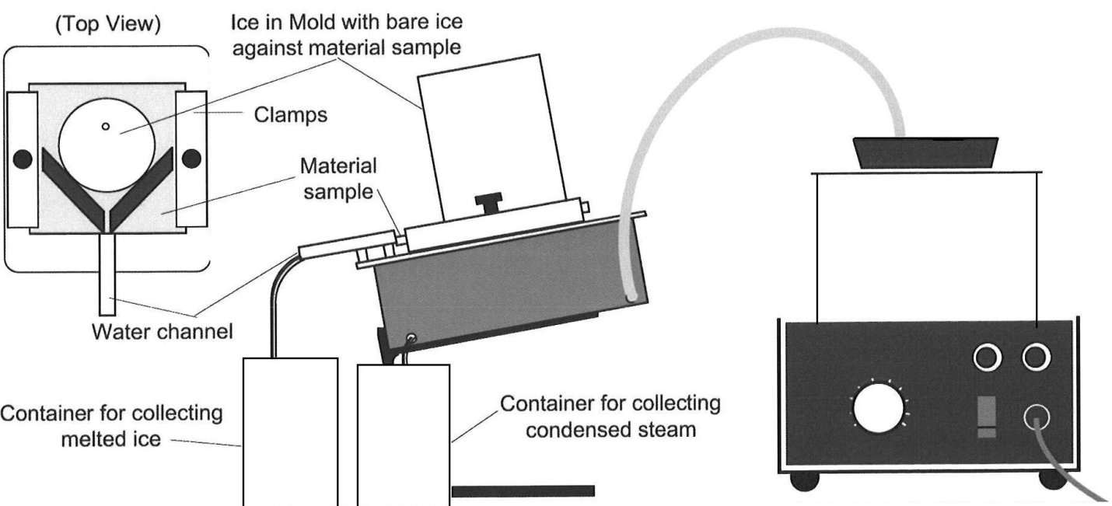

Theory
Heat can be transferred from one point to another by three common methods - conduction, convection and radiation. Each method can be analyzed and each yields its own specific mathematical relationship. The equation giving the amount of heat conducted through a material is
$Q=\frac{kA\left(T_{H}-T_{C}\right)t}{h}$ (1)

where Q is the total heat energy conducted, k is the thermal conductivity of a given material, A is the area through which conduction takes place, T_{H} is the temperature on the hot side of the material, T_{C} is the temperature on the cold side of the material, t is the time during which the conduction occurs, and h is the thickness of the material. The units for the thermal conductivity depend upon the units used to measure the other quantities involved but the importance of k lies in whether one wishes to conduct heat well (good conductor) or poorly (good insulator). Therefore, the relative size of k is of importance to home designers, builders, and home owners.

The technique for measuring thermal conductivity is straightforward. A slab of the material to be tested is clamped between a steam chamber, which maintains a constant temperature of about 100°C, and a block of ice, which maintains a constant temperature of 0°C. A fixed temperature differential of about 100°C is thereby established between the surfaces of the material. The heat transferred is measured by collecting the water from the melting ice. The ice melts at a rate of one gram per 334 joules of heat flow (the latent heat of melting for ice). This rate of melting can then be used to determine the thermal conductivity

$Q=\frac{kA\left(T_{H}-T_{C}\right)t}{h}=mL_{f}$ (2)

where m is the mass of the ice melted during time t and L_{f} is the latent heat of fusion for water. The thermal conductivity can then be determined

$k=\frac{mL_{f}h}{A\left(T_{H}-T_{C}\right)t}$ (3)

Equipment Needed
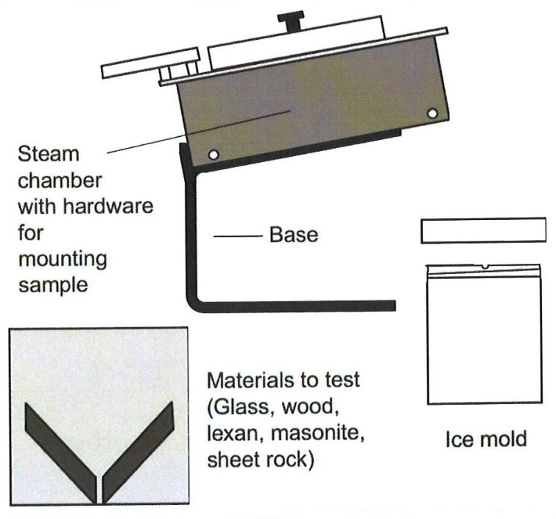
- Thermal conductivity apparatus consisting of the base stand, the steam chamber with the hardware for mounting the materials, ice molds with covers, sheets of materials to be tested – glass, pine, Plexiglass (Lexan), Masonite, sheet rock (where the pine, Masonite, and sheet rock are covered with aluminum foil for waterproofing)
- Steam generator with tubing
- beakers
- digital balance
- freezer

Procedure
- Measure and record the thickness of the sample material (h).
- Mount the sample material onto the steam chamber taking care that the sample material is flush against the water channel, so water will not leak, then tighten the thumbscrews.
- Run steam into the steam chamber. Let the steam run for several minutes until temperatures stabilizes so that the heat flow is steady. Make sure to place a container under the drain spout of the steam chamber to collect the water that escapes from the chamber.
- Run an ice mold under warm water to loosen the ice in the mold - do not attempt to “pry” the ice out of the mold. When the ice has thawed enough to slide out of the ice mold, measure the diameter of the ice cylinder and calculate the cross sectional area A.
- Place the ice on top of the sample, exposing only a centimeter of ice and holding the ice mold to keep the ice in a fixed position.
- Let the ice sit for several minutes so it begins to melt and comes in full contact with the sample. Don't begin taking data before the ice begins to melt, because it may be at a lower temperature than 0°C.
- Once the steady rate of melting has been established, replace the beaker that was used to catch the water from the melting ice (waste beaker) with a dry beaker and begin the timer.
- After a significant amount of time (six to ten minutes) has passed stop the timer and replace the catch beaker with the waste beaker. Record the time that has elapsed (t).
- Remove the ice from the sample and measure the mass of the melted water in the catch beaker (m).
- Using gloves, carefully remove the lid to the steam generator, select the next sample, and check that there is enough ice left in the ice mold for the next sample.
- Repeat the procedure for the remaining samples.
- Using the experimentally determined and literature provided thermal conductivities, calculate the percent error for each sample using the equation below.

$$Percent Error=100\% x \frac{k_{Exp}-k_{Lit}}{k_{Lit}}$$

Thermal Conductivity Data Sheets

Material: Glass
Thickness of material =
Diameter of ice =
Time period =
Mass of water melted =
Temperature of steam =
Temperature of Ice =
Thermal Conductivity of glass =
Literature value =
Percent Error =

Material: Plexiglass (Lexan)
Thickness of material =
Diameter of ice =
Time period =
Mass of water melted =
Temperature of steam =
Temperature of Ice =
Thermal Conductivity of Plexiglass =
Literature value =
Percent Error =

Material: Pine
Thickness of material =
Diameter of ice =
Time period =
Mass of water melted =
Temperature of steam =
Temperature of Ice =
Thermal Conductivity of pine =
Literature value =
Percent Error =

Material: Sheet rock (Gypsum)
Thickness of material =
Diameter of ice =
Time period =
Mass of water melted =
Temperature of steam =
Temperature of Ice =
Thermal Conductivity of sheet rock =
Literature value =
Percent Error =

Questions

- What would likely be a significant source of error in performing this experiment on other materials that have very low thermal conductivities that you would not see for materials that have higher thermal conductivities?

- What would likely be a significant source of error in performing this experiment on other materials that have very high thermal conductivity that you would not see for materials that have lower thermal conductivities?

- List the materials used in this experiment in order of decreasing thermal conductivity (literature reported) and then provide the corresponding percent errors observed. What trend do you notice in the data (if any)?

- Would there be any advantage to wrapping the Plexiglass and glass samples in aluminum foil like the pine and sheet rock were?

