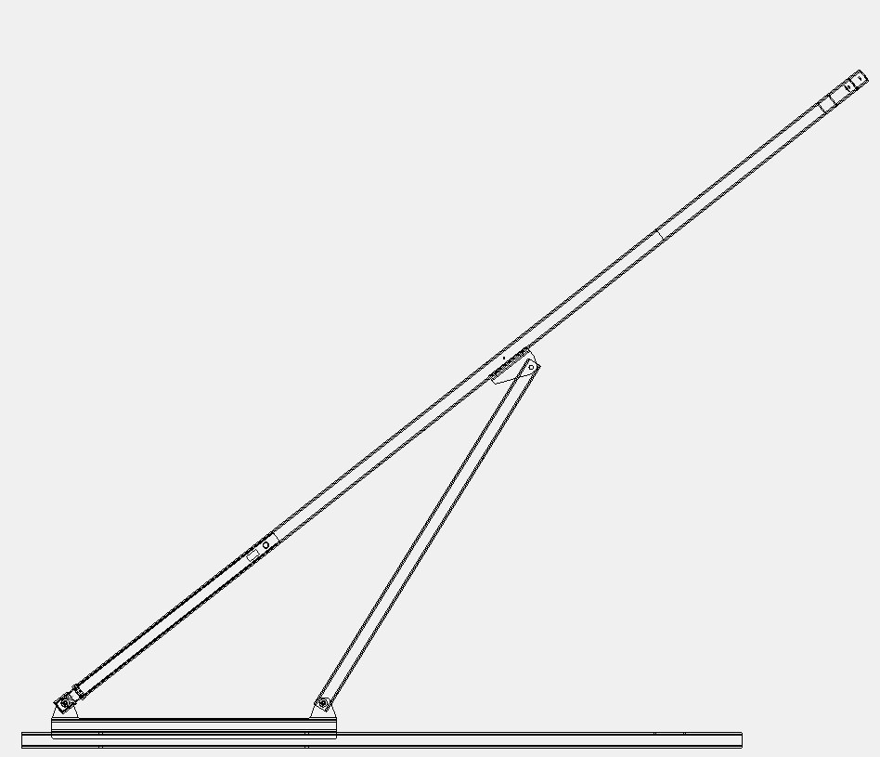
INSIDE LEG1
PIVOT 3
GAS SPRING REAR MOUNT POINT
GAS SPRING FRONT MOUNT POINT
LEG 2

LEG 3

PIVOT 2
PIVOT 1
Force?????

°

°

21.5inches

°

°

37inches

°

°

32inches

°

°

51inches

°

°

40°

°

°

62°

°

°

