The Fixed end of the 120lb compression spring is connected only to the short tube (green color) only.
The movable end of the gas spring is connected to the longer outer tube using a sex bolt which slides in the slot build in the shorter tube.
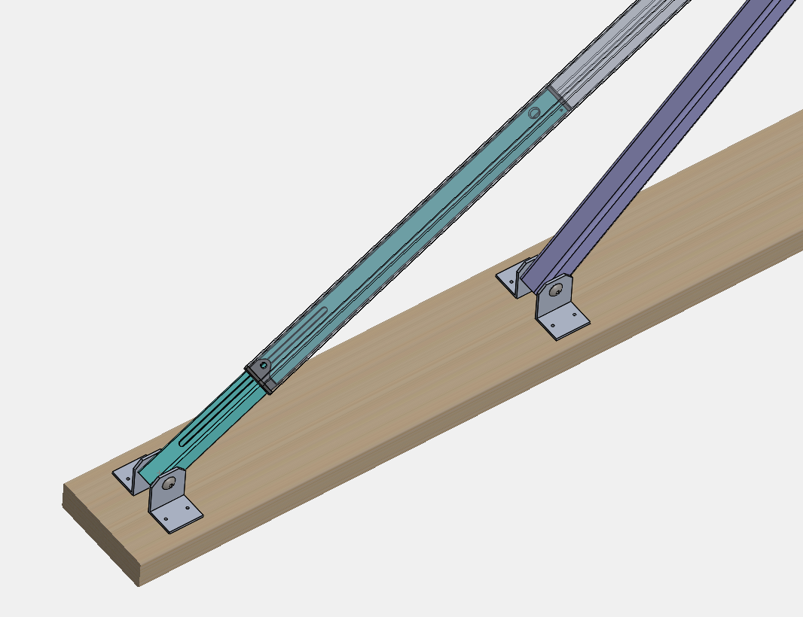
23’’
Gas Spring Fixed end mount point
Gas Spring Movable end mount point

Length of Short tube (telescopic to transparent) = 23in
The total length of long tube = 83in



