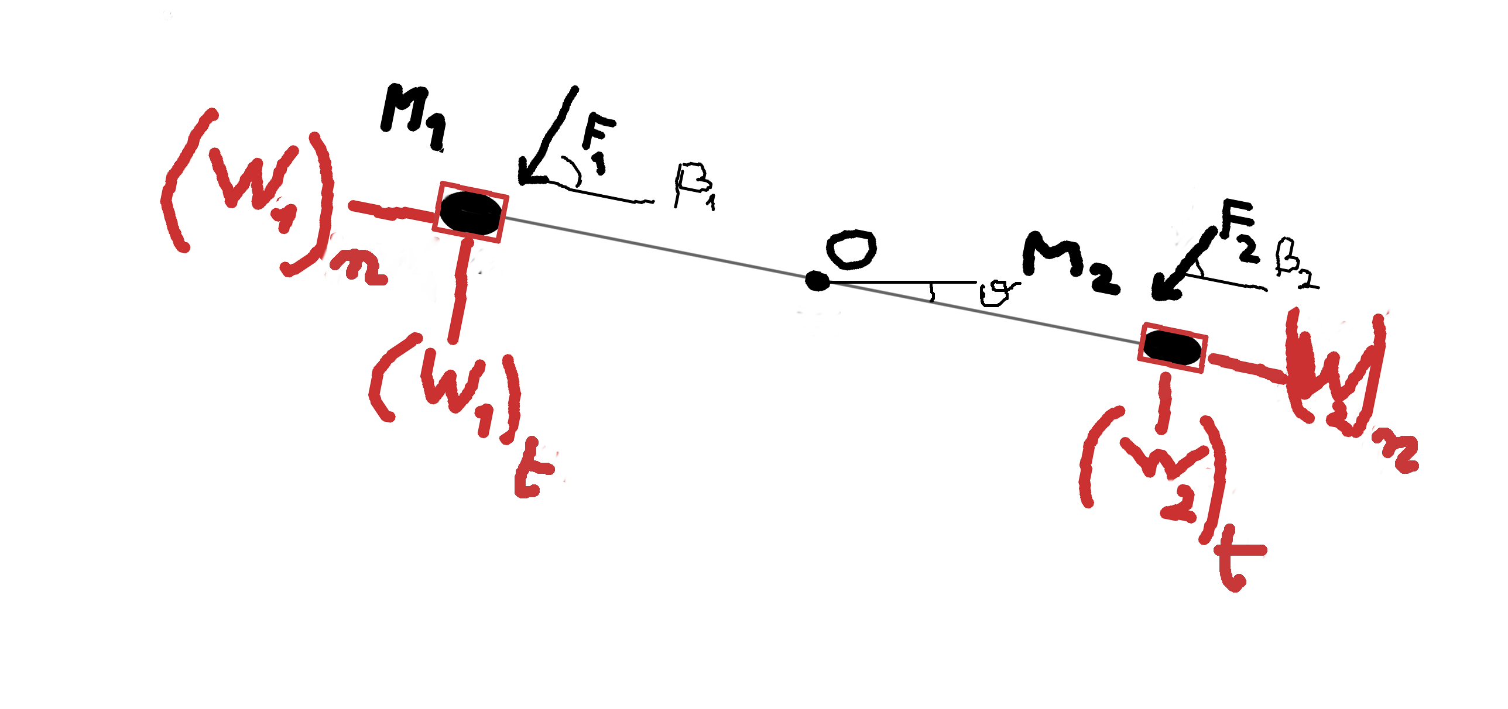
1. (W₁)_{n}= M₁ω²r+F₁sinβ₁+ M₁gsinθ
2. (W₂)_{n}= M₂ω²r+F₂sinβ₂+ M₂gsinθ
3. (W₁)_{t}= M₁gcosθ+F₁cosβ₁-M₁αr
4. (W₂)_{t}= M₂gcosθ+F₂cosβ₂-M₂αr
5. F₁cosβ₁r+M₁grcosθ-M₁r²α= F₂cosβ₂r+M₂grcosθ+M₂r²α
dθ/dt=ω
dω/dt=α

