Gary’s Physics Problem

In college physics we learned that the magnetic field due to a long current-carrying wire can be written $B\left(d\right)=μ_{0}I/2πd$, where $d$ is the distance to the wire, $I$ is the current, and $μ_{0}$ is the magnetic permeability of free space. The direction of the field can be found from applying the “right hand rule” in the direction of the current.
We also learned that if there are two long wires carrying equal current in opposite directions , the combined magnetic field from both wires is the vector sum of the field contributions from each wire. The figure below shows the combined field in such a case. FYI - I grabbed this snapshot from here.
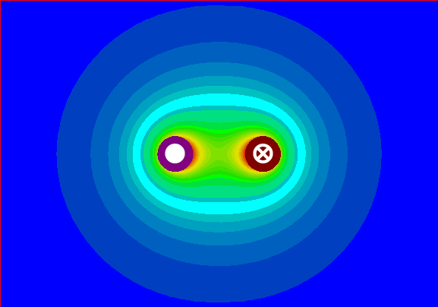

In an AC power cable, there are typically 3 conductors – hot (black), neutral (white) and ground (green). Fig. 1 below shows a cross-section of such a cable.
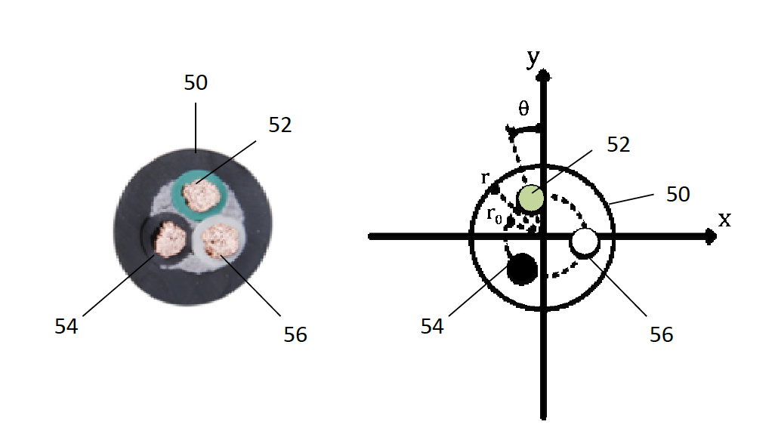
Figure 1 Cross-section of a 3-conductor AC power cable.
Fig. 2 shows the combined magnetic field around such a cable when hot and neutral leads carry 1 Amp DC in opposite directions. This example assumes an outer insulator radius of $r$ = 8 mm and a distance of 5 mm from the center of the cable to the conductor. I generated this figure in Matlab – I can provide the script if desired – just let me know.
Figure 2 Magnetic field in and around a 3 conductor AC power cable with hot and neutral conductors carrying equal current but in opposite directions (i.e., to and from a load). The bold black dotted line represents the outer insulator of the cable. Current flow is out of and into the page for the upper and lower-left conductors, resp.
Figure 3 shows the magnetic field strength around the outer insulator of the AC cable of Fig. 2 at r = 8.0 mm with both conductors carrying current (blue trace) and only one conductor carrying current (green trace).
Figure 3 Field strength around the outer insulator of the cable of Fig. 2. The green trace shows what the field would look like if only one of the two leads had current.

Now let’s assume we place a ferrite toroid around the outer insulator of the cable, and wrap N turns of magnet wire around a small angular region of the toroid. Let’s further assume that we apply an AC voltage to the power cable and drive AC current to a load. The AC current should induce a time-varying voltage that’s proportional to the time derivative of the flux linkage in the coil around the toroid.
The diagram below shows the setup.
To voltmeter
N turns of magnet wire
3-conductor AC power cable, current flow: (black) out of page (orange) into page (green) no current flow (ground)
Ferrite Toroid

The figure below shows a measurement setup I was using to test various theories in this write-up. The cable and toroid in the figure have about the same dimensions as the examples of Figs. 2 and 3. For my testing, I was using a space heater as the load – it was drawing about 12 Amps RMS at 120V.
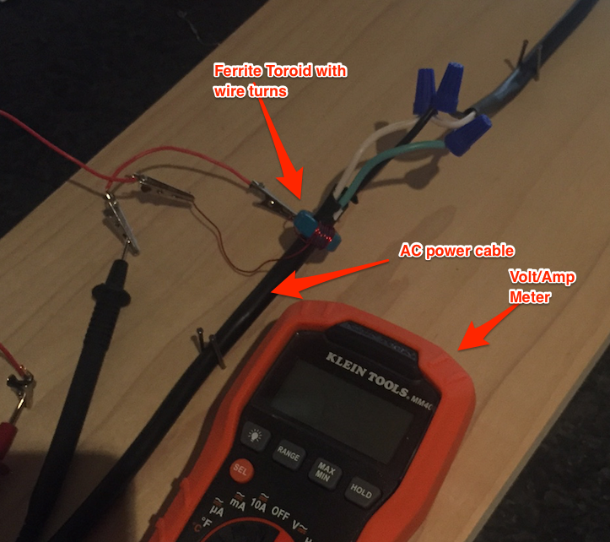
Figure 4 Experimental test set-up.
My problem: When I put the toroid around just the hot wire and turn on the space heater to draw current, referring to the green trace of Fig. 3, I expected to measure a much higher voltage (according to Fig 3, more than 4x as much voltage) when the wire coil is put very close to the hot wire vs. when it’s far away. But I didn’t see this happening at all – I saw very little change in the voltage regardless of where I moved the coil around the toroid relative to the hot wire. It was about 90 mV RMS regardless of angular position.
Also, referring to the blue trace of Fig. 3, when I put the toroid around all 3 wires, I expected to see a significantly higher voltage when the coil is located near either the hot or neutral leads than when furthest away from both. But in this case I saw only a very small voltage (pretty much zero due to the phase cancellation) regardless of where I positioned the coil around the toroid.
So what gives? My understanding of ferromagnetic materials is that they have the effect of boosting the magnetic field strength at any point in space – and boosting it in a linear, multiplicative way assuming there’s no saturation (which in this case I don’t think there is). Referring back to the example of Fig. 2, I’d expect the field strength inside the toroid to look like that of Fig. 5 below. But what appears to be happening is that the toroid is spatially “averaging out” the magnetic field and presenting a constant magnetic field regardless of the angular position of the coil relative to the current-carrying conductors. Is this what’s happening? If it is, is there another material I can use that won’t do the “spatial averaging” thing? If so, I think there’s a real market for it!!
Figure 5 Example of Fig. 2, with a toroid with relative permeability 10 placed around the cable outer insulator. All I did here in my Matlab was multiply the magnetic field by a factor of 10 in the toroid region. Is this a good way to represent physical reality? Certainly doesn’t seem to agree with my measurements!!!

