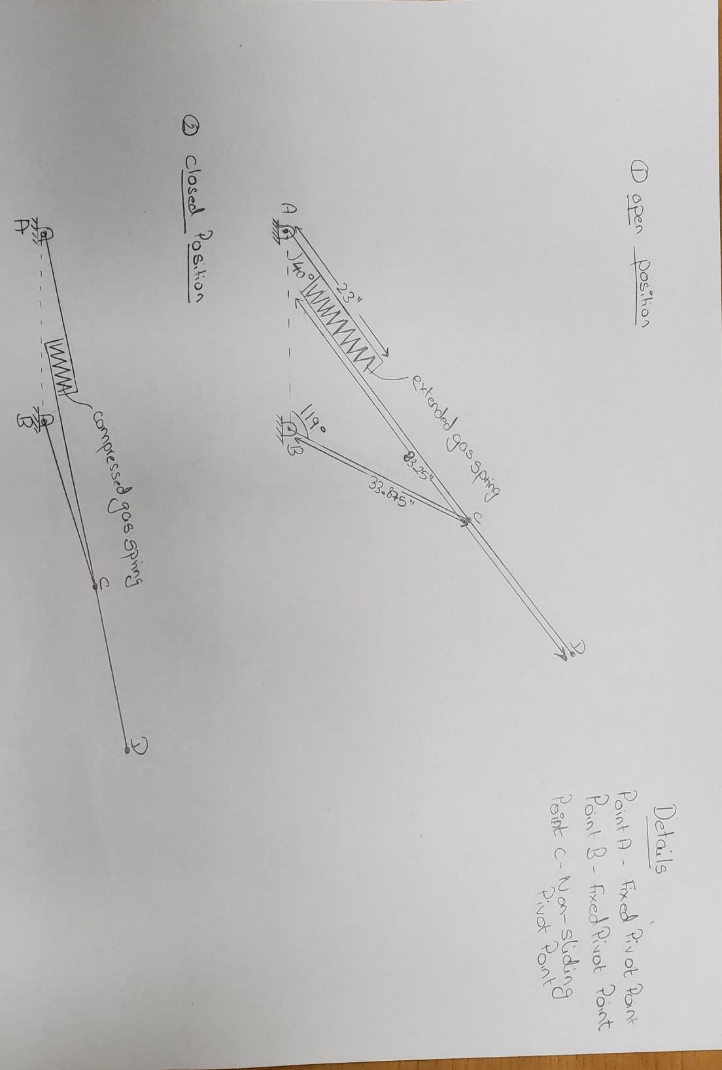

I am sorry I am not quite sure on how to depict the mount points and working of the gas spring in the line diagram. Please see below the detailed explanation with CAD images.

Arm at Open Position:
D
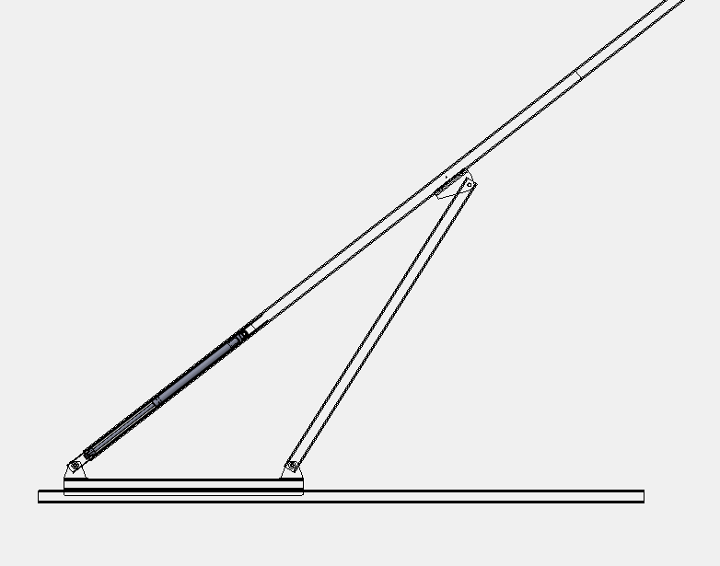
120lb
Force=?
C
A
B
Arm at Closed Position: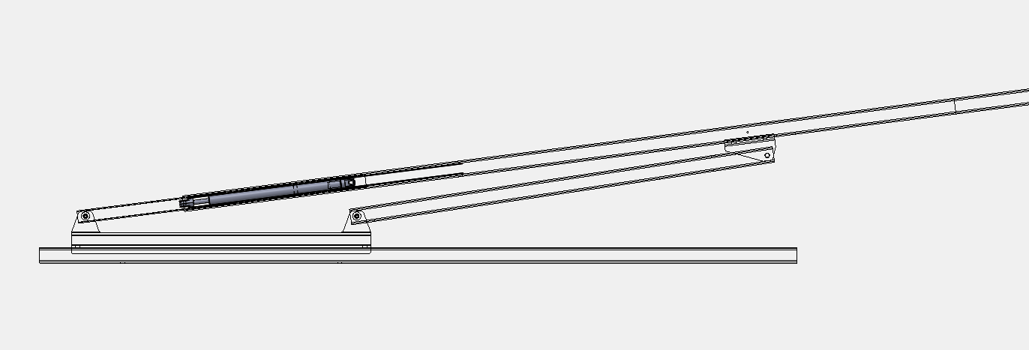

Gas Spring Direction and Mount Points Images:
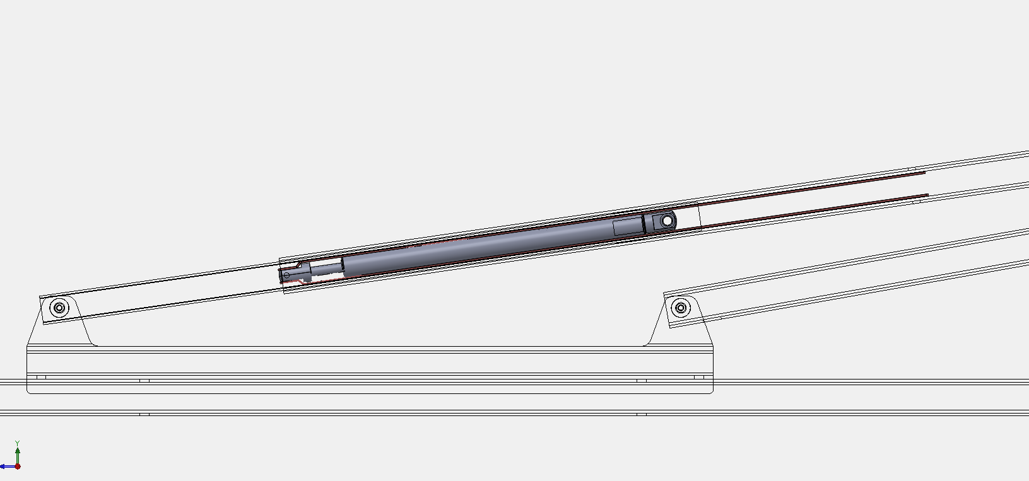
G
F
E
B
A
The gas Spring is totally inside the smaller tube.
Point F: Fixed End of gas spring mounted to the inner tube.
Point E: Extendable End of gas spring fastened to 2 metal plates (Orange color plates shown in above image)
Point G: Orange plates fixed point on the outer tube.
Stroke Length of Gas Spring: 8in

Questions:
Would like to draw a free body diagram to analyze the forces and moments in the system. Currently the gas spring is rated for 120lb. What force would be needed to pull the arm AD down from open to closed position. I want to get a total understanding of all the forces in the system and later make modifications to improve it.

