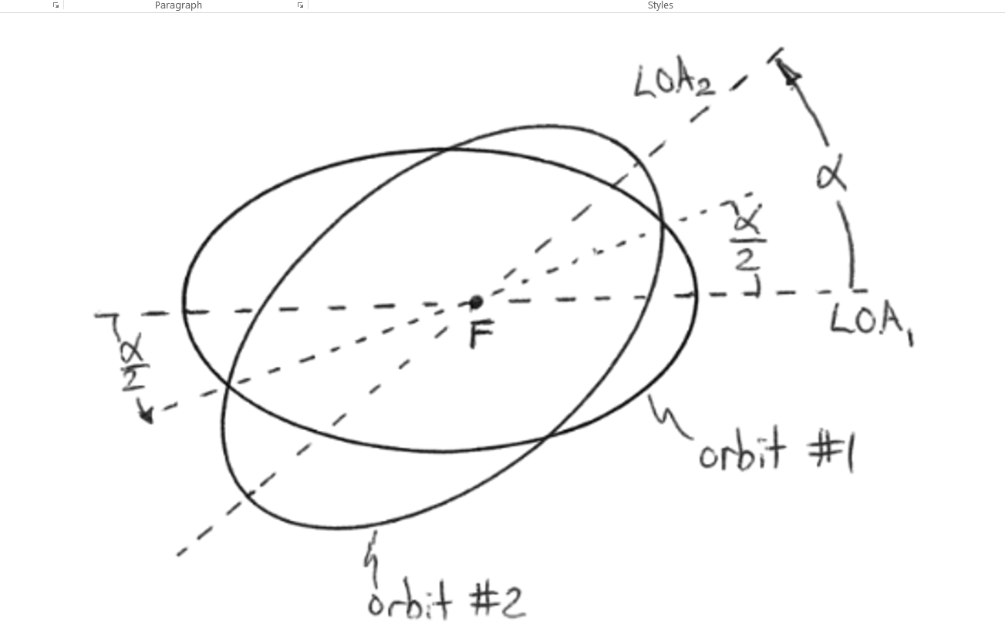

The inherent property of the Vilarso circles is to position the sphere toroidal shell between two arbitrary ribs adjacent to the planes of symmetry. The half angles in between adjacency plane and the up_scaled toroidal “latitude” thence plays the part of some quasi”symmetry placed on the equatorial line of tilting up until the sphered shell becomes at least two circles. It is only then that generation of complete groups gives way to the Focal Point (F) with the first rib virtually drawing the tilt half-angle while the second rib thus procreated turns the first virtuality into an actual bifurcation plane. If there are two arbitrary adjacent ribs in the rotations of the motion meridian disk, (quazi—)symmetry is lost

