Making the Torbus cup 171618

The “Torbus Cup” is similar to the “Klein Bottle” except the tube passes through an open hole in the cup body. The Geometry of a Mobius ring will be the starting point to understand the construct of the “Torbus Cup”. Two Mobius Rings are needed; one counter rotated from the other. Figure 1 shows the juxtaposed pair of rings. The concept used in morphing this mated pair to form geometry similar to the Klein bottle is to join the edges and only the edges of the two strips as shown in Figure 2. The red hole in Figure 2 is the result of joining only the edges of the brown and green rings which allow the resulting tube to pass through the sphere at the red hole. As seen in Figure 2 the ring AB is the lip of a funnel. The tube attaches to the funnel before passing through the red hole. After sassing through the hole the tube begins to expand at points 1 and 2 to form the sphere that attaches to the funnel lip, thus completing the new geometry.

A clastic computer drawing of the “Klein Bottle” is shown in Figure 3. A simple construct of this new geometry, now called a “Mobius Cup” is shown in Figure 4, is to use a plastic jar, funnel, and a tube.
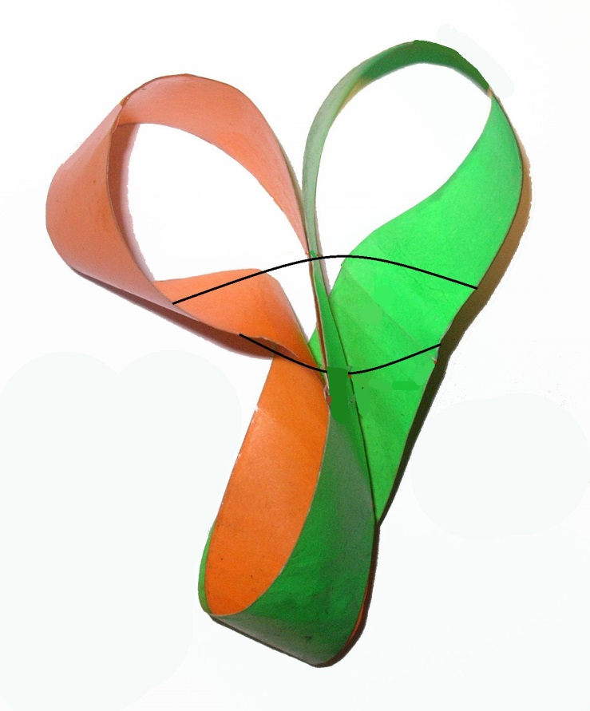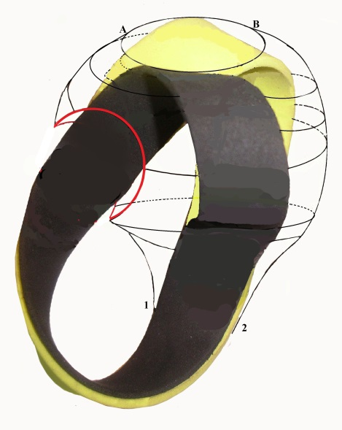
Figure 1 Juxtaposed counter rotated Mobius Rings Figure 2 Morphing rings to a Mobius Cup

The Mobius ring has only one surface and one edge thus, the Mobius cup has only one surface and one edge.

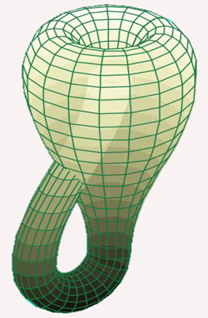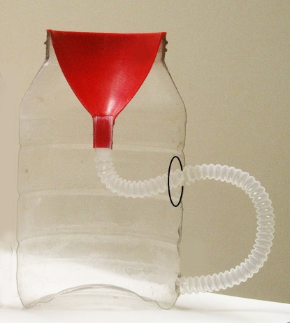
Figure 3 computer drawing Figure 4 Mobius Cup
of a Klein Bottle.

This morphing is shown in an animated video; frames of which are its edges separate. In the reverse order a tube is stripped from the torus to first form the funnels lip, then the cups handle and cup body. As the tube end edge moves over the funnels edge they bond edge to edge then move on to the handle. Since the hole edge is at the handles surface it cannot bond, edge to surface cannot bond see Figures 1 and 2; neither can surfaces bond, only edges bond.

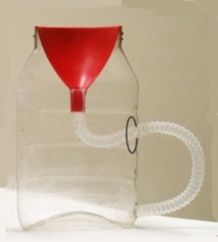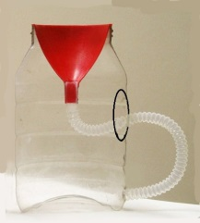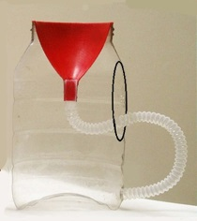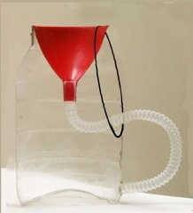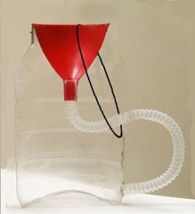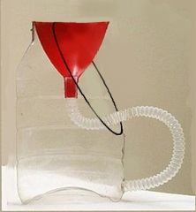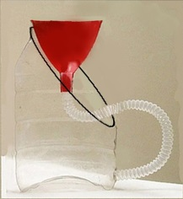
1 2 3 4 5 6 7
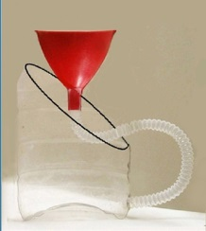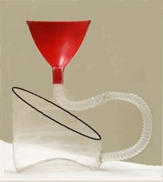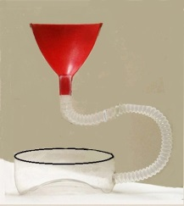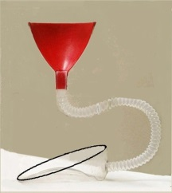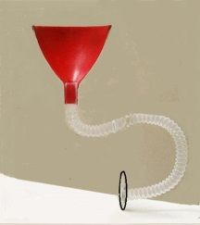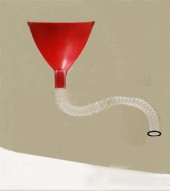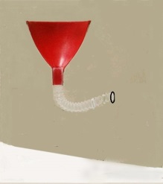
8 9 10 11 12 13 14
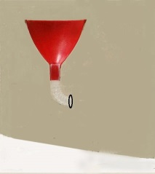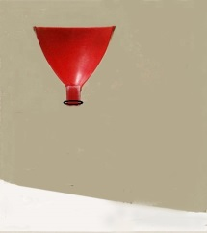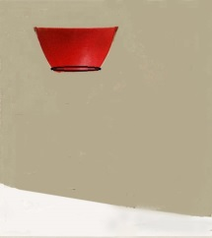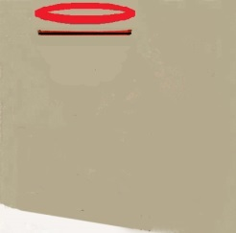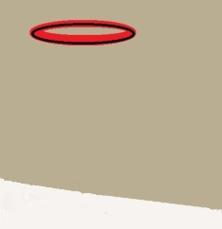
15 16 17 18 19
Figure 5 Video frames of animated morphing a Torus to form a “Mobius Cup”
Adding two strings to the Mobius Cop will make it a “Torbus Cup” because it will then have a pair of Torbus Rings laminated to its edge. A “Torbus Ring” is one half of a Torbus; a Torbus is a Torus divided into two pieces as shown in Figure 6A. by cutting a one sided ring from the Torus it can be separated in to two pieces called the Torbus ring and its compliment Figure 6B, before the two pieces are separated the geometry is called a “Torbus”. Notice that the ring cut in the Torus is not a Mobius Ring, as shown in Figure 7. The compliment ring is a laminate of the Torbus ring; if a piece of paper is cut into stripes the strips can be used to laminate a Mobius ring, but the strips will not laminate the Torbus ring see Figure 8. Figure 7A shows the Mobius Ring is not coplanar, whereas the Torbus Ring is shown to be coplanar in Figure 7B. By definition the axis ring of a Torus is coplanar therefore the axis ring of a Torbus Ring is coplanar. Stored force in the twist of a Mobius ring distorts its axis ring.
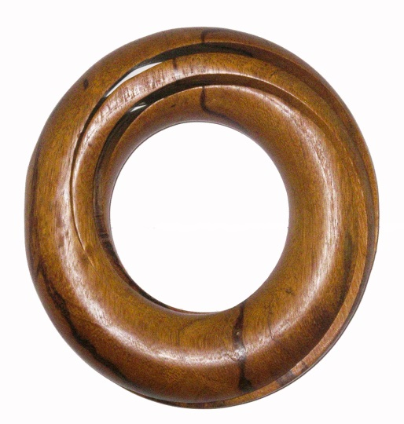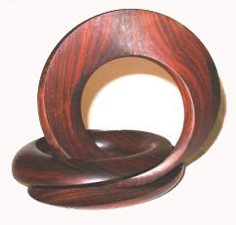
A B
Figure 6 A) is a picture of the geometry of a Torbus cut from exotic wood. B) Is a picture of a splayed Torbus showing the one sided ring (vertical) and its compliment ring (horizontal).
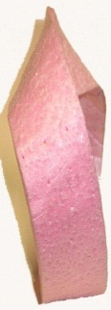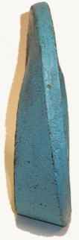
A B
Figure 7 A) is a Mobius Ring and B) is a Torbus Ring
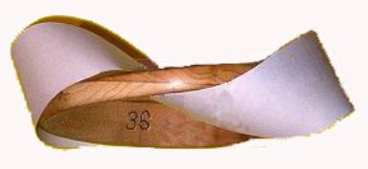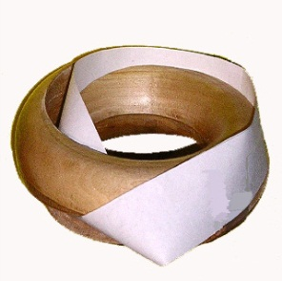
A B
Figure 8 A) Shows a Mobius Ring will not laminate a Mobius Ring
B) Shows the Compliment Ring will not laminate a Mobius Ring.
If a string is cut to the length of the single edge identified in Figure 9 A) as ABCDEFGHIJ it can be laminated
(attached) to the edge of Figure 9 B) or it could be paced on the inside surface and outside surface of the cup as shown in Figure 9 and Figure 10. The string can also be called a continuous laminate of the cups inside and outside surface.
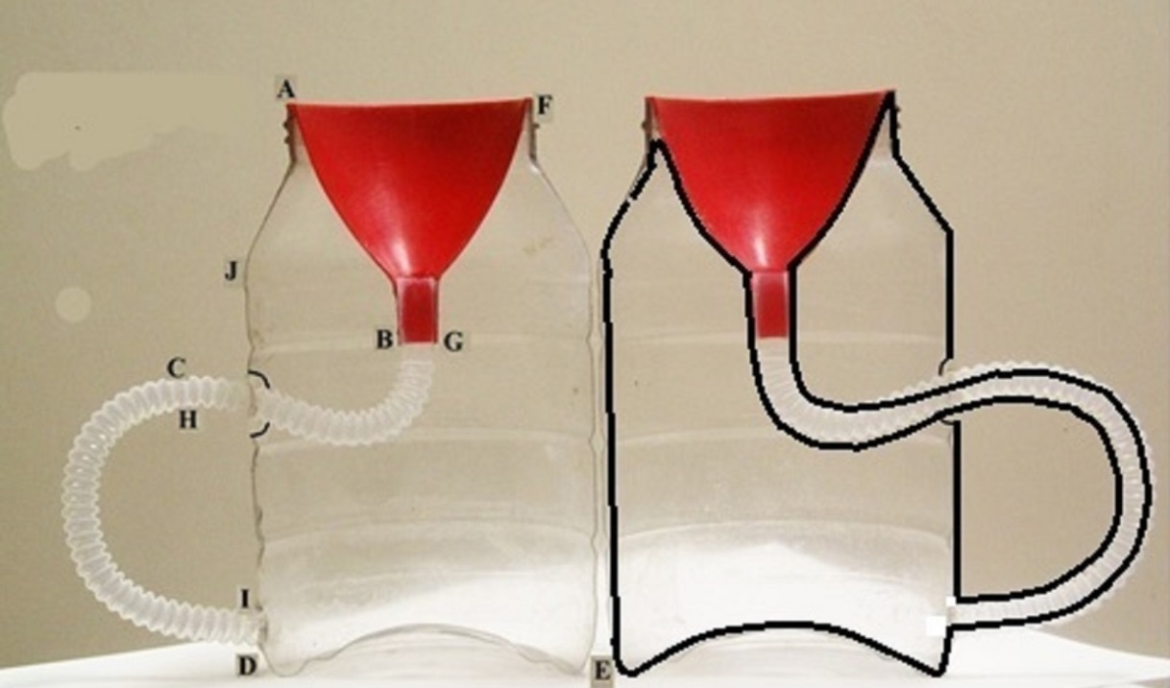
A B
Figure 9 A) and B) are mirror images of the two half surfaces of a Mobius Cup.
- is the path of the edge and B) shows a string attached to the edge of A’s cup mirror image,
or it can be considered a laminate to the cup’s surface.

Two such strings can also be placed in the two halves of the Mobius Cup ( now called a “Torbus Cup”) shown in Figure 10; their strings only have a path in and on the half they are placed in though they are in the same cops volume .
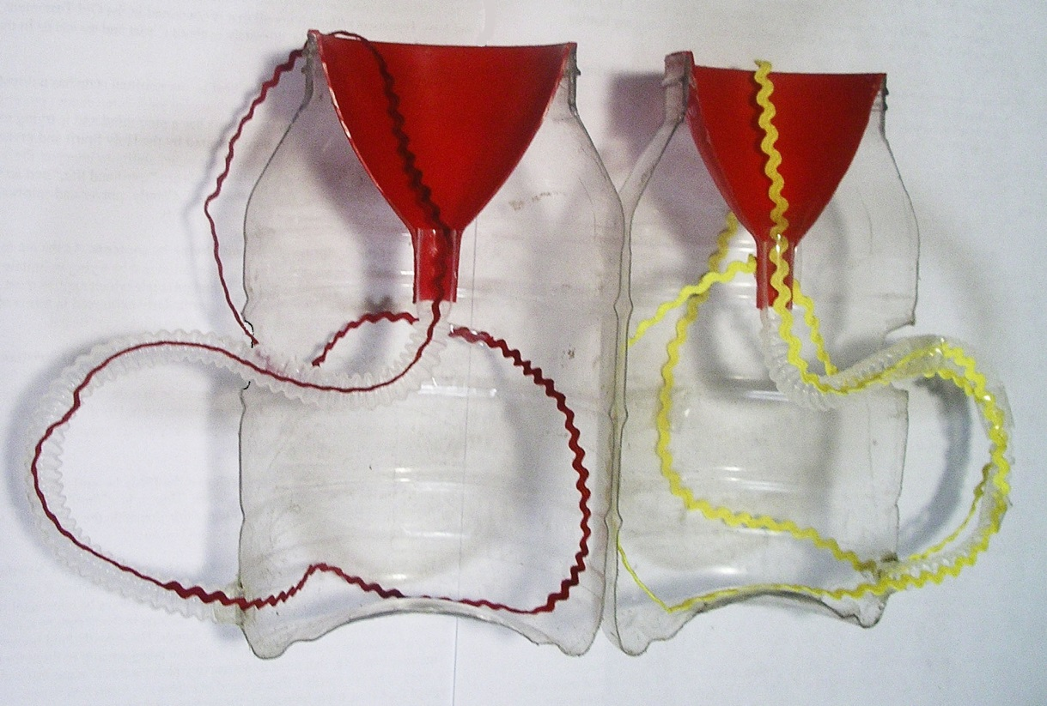

Figure 10 Two string laminates placed in the two halves of the Torbus Cup
The four ends of the strings can be attached in several ways to travel through the cop’s volume. A third string with its ends attached to the two strings in Figure 10 will travel inside and outside the “Torbus Cup” volume as shown in Figure 11. In Figure 11 note that the exit hole and the entrance hole for the handle are interchanged from Figure 10, this is so the movement of the strings will be smother when the two half cups are put together.
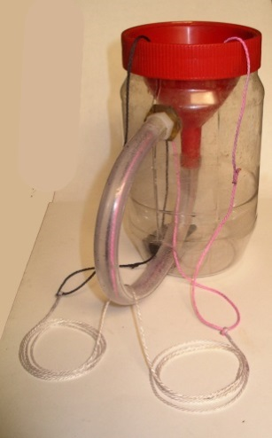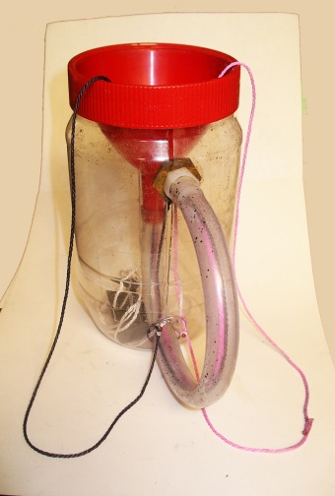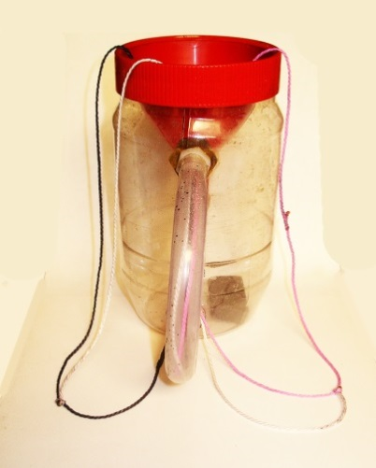
A Third string outside the cup B Third string inside the cup C Third string passes through the cup

Figure 11 Shows that a white string attached to the black and red strings can have
different positions in the Torbus Cup.
- the string is outside the cup and passes through the handle.
Also it can be totally outside at the top of the cup
- the string is totally inside the Cup.
- the string passes through the cup with both ends are outside.

Perhaps this is a little more clear explanation of what a Torbus cup is by referencing it to the Klein Bottle.

If more information is desired for the various Torbus puzzles that have been made from exotic woods please visit my Facebook page. There you will find I need some help solving Topology problems involving the extraction of the “Torbus Ring” from the “Torus and its movement around and through its “Compliment” Laminating Ring. See the attached animation XXXXXXXXXXX

