*Passing string ptr for Dynamic mem, back from function: See picture below. void getMem(string**);
int main(){string St1; string *sptr; getline(cin, St1)//Paul;
sptr = &St1 //sptr=address St1; getMem(&sptr)//passing address spt; cout << *sptr//Alan;
cout << st1//Alan; delete[]sptr;} void getMen(string **mptr){string St2; St2 = **mptr//St2=St1;
cout << St2//Paul; St2 = ”Alan”; **mptr = St2//*mptr = &St1;} return from function, “Alan” is in St1.
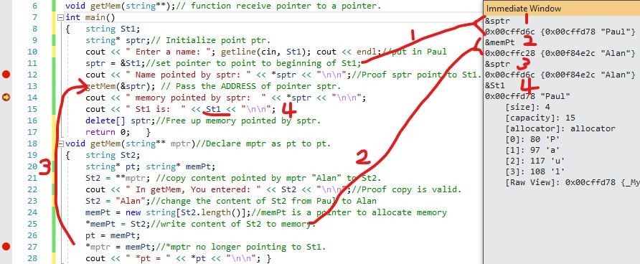
*1) show address of sptr(&sptr)=0x00CFFD6C, content in address(sptr)is 0x00FFD78 is address of St1.
Content in St1 is “Paul.
*2) Show address of mmpt(&mmpt) is 0x00CFFC28, content in address(mmpt) is 0x00F84E2C is the
address of the start of Dynamic allocated memory. It is used to allocate memory.
*3) mptr is pt to pt, *mptr is address of pointer. It was pointing to St1 in main when passing to getMem.
The content of memPt(start address of memory) is copied to *mptr. Now *mptr points to the memory.
*4) When return to main, sptr is pointing to memory, not to St1, content of St1(Paul) remains.

*Passing pointer as reference: For array: void func(int*&); main(){..func(ptr)..} void(int*&pptr){pptr = Ar..}
*P522: Return pointers from function: declare int*func(parameters); last line return ptr;
-Note that if ptr points to a local variable in function, it will be destroyed when exiting function. Need to
point to a reference variable passed into function. OK to point to array Ar[] as Ar is address to Ar[0].
*P532: Array of pointers: type*Ar[size]. Just treat each a pointers.

