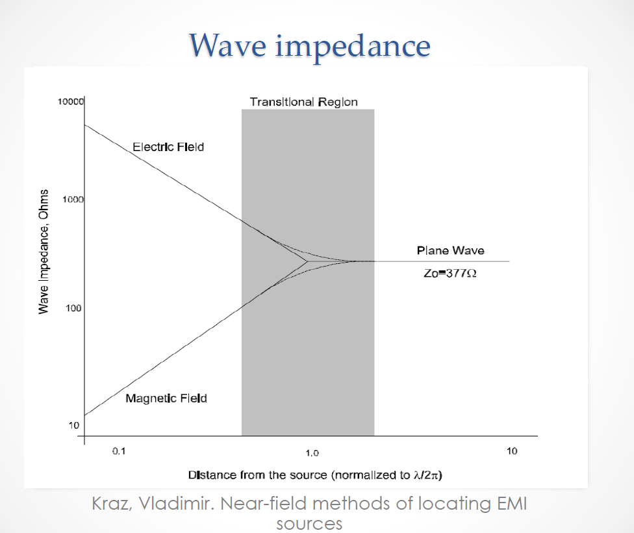
This picture is taken from the following presentation available on the web: Magnetic Field Probes: What it is and how to make it (if you don’t want to buy it), Khairul Aidi Zainal, Marquette University Microwave Seminar, May 2nd 2014

