Pressure loss calculation
Design Input for pressure loss double wall air pipe calculation.
- Fluid : air
- Double wall pipe (stainless steel) with outer pipe OD89mm, wall thickness 3mm, inner pipe OD61mm, wall thickness 2mm. the air will blow into the void between inner and outer pipe
- Pipe distance : 7m.
- Number of 90 degree elbows : 7 pcs
- Number of plastic support to inner pipe : 9 pcs
- Air flow capacity 30 m3/h equivalent 0.0083 m3/s.
- Air velocity = 0.0083/0.002529 = 3.3 m/s

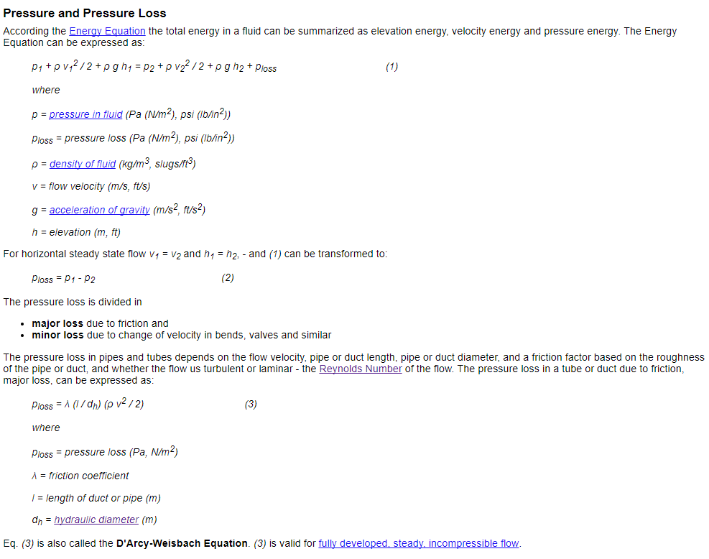
- Major loss due to friction calculation.
1A. Hydraulic diameter
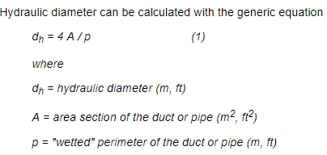

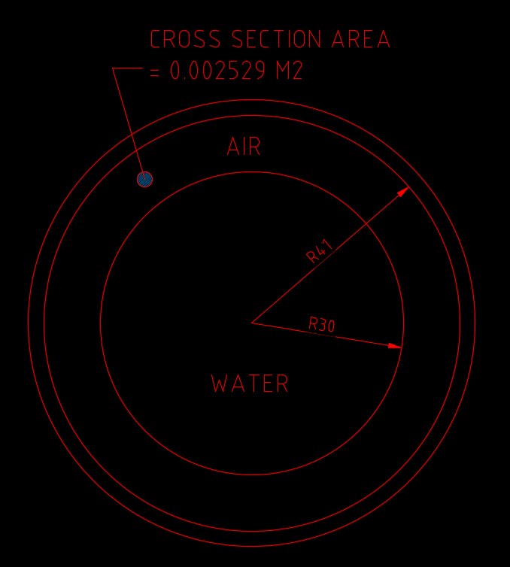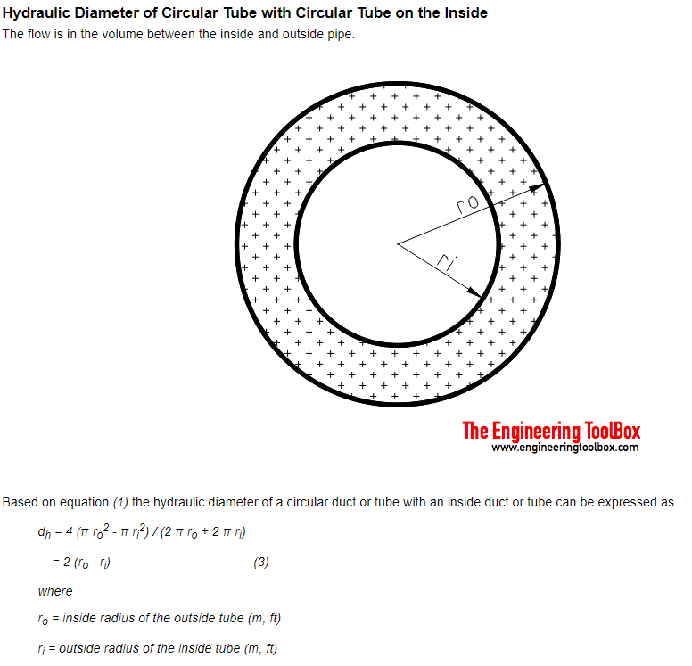

d_{h} = 4 (π r_{o}² - π r_{i}²) / (2 π r_{o} + 2 π r_{i})
= 2 (r_{o} - r_{i})
= 2 (41-30) = 22 mm

1B. Friction Coefficient λ
The friction coefficient - λ - can be calculated by the Colebrooke Equation:
1 / λ^{1/2} = -2,0 log₁₀ [ (2,51 / (Re λ^{1/2})) + (k / d_{h}) / 3,72 ]
where
Re = Reynolds number
v = velocity (m/s)
ρ = density of air (kg/m³)
k / d_{h} = the relative roughness - or roughness ratio

Reynolds Number for a Pipe or Duct
For a pipe or duct the characteristic length is the hydraulic diameter.
L = d_{h}
where
d_{h} = hydraulic diameter (m, ft)
μ = dynamic or absolute viscosity (Ns/m²) (calc. at 0 deg C)
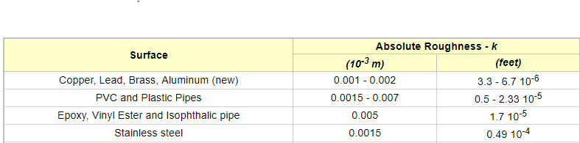
The Reynolds Number for a duct or pipe can be expressed as
Re = ρ v d_{h} / μ
Re = (3.3 m/s) (0.022 m2 ) (1.23 kg/m³) / (1.79 10⁻⁵ Ns/m²)
Re = 4988.7
Turbulent flow indicates that Colebrooks equation (9) must be used to determine the friction coefficient - λ -.
With roughness - ε - for stainless steel 0.0015 mm, the roughness ratio can be calculated:
Roughness Ratio ε = k / d_{h}
= (0.0015 mm) / (22mm)
= 0.00006818
Using the graphical representation of the Colebrooks equation - the Moody Diagram – or refer to (http://www.advdelphisys.com/michael_maley/moody_chart/) the friction coefficient - λ - can be determined to:
λ = 0.0375
The major loss for the 7 m pipe can be calculated with the Darcy-Weisbach Equation (3) or (6):
p_{loss} = λ ( l / d_{h} ) ( ρ v² / 2 )
= 0.0375 ((7 m) / (0.022 m)) ( (1.23 kg/m³) (3.3 m/s)² / 2 )
= 79.9 Pa
- Minor loss due to change of velocity in bends.
p_{minor_loss} = ξ (1/2) ρ v² (1)
Loss coefficient elbow’ ξ usually more and less 0.2 for regular 90 degree 1,5D.
Delta P = 1.5x0.5x1.23x3.3²=10 Pa
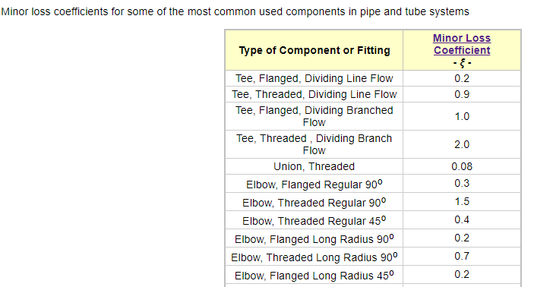
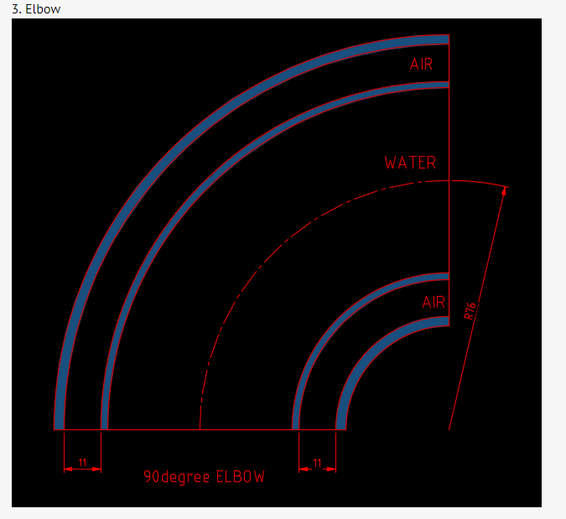
Hi Chestermiller , can you please advise as following:
- My calculation to major loss due to friction calculation is correct or not?
- My calculation to minor loss due to change of velocity in bends is correct or not?
- The pressure loss to inner pipe support ring is quite difficult as I really have no idea how to calc. because the shape of the air hole is odd. Can you please provide your thoughts?
- 

