Problem with Directory 3
1) delete .dat before running.
2) If put fileV.DirV[index].firstName in comment: if (fileV.DirV.size() > 0)
{do { cout << " Element #[" << fileV.DirV[index].element <<
"] is: Last name: " << left << setw(10) << fileV.DirV[index].lastName <<
" first name: " << left << setw(10) <<
// fileV.DirV[index].firstName <<
"\n\n";
Then type a and enter t, e, y, u, i, n. Then quit. When run again, and type s, this is the screen.
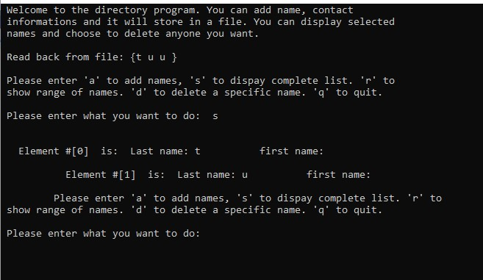

But if taking out comment on fileV.DirV[index].firstName <<
if (fileV.DirV.size() > 0)
{do { cout << " Element #[" << fileV.DirV[index].element <<
"] is: Last name: " << left << setw(10) << fileV.DirV[index].lastName <<
// " first name: " << left << setw(10) <<
fileV.DirV[index].firstName <<
"\n\n";
Then type a and enter t, e, y, u, i, n. Then quit. When run again, and type s, this is the screen.
: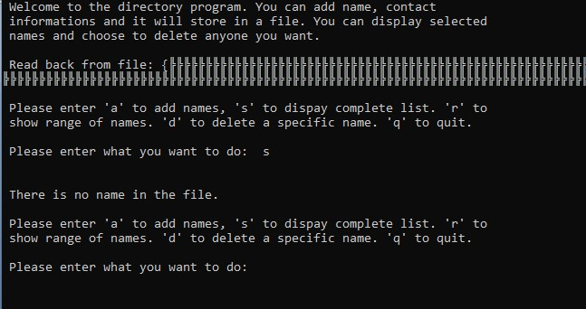
When quit, it said subscript of DIRV out of range.
Reset computer seems to stop this.

