55. The double Atwood machine shown in Fig. 4-50 has frictionless, massless pulleys and cords. Determine (a) the acceleration of masses $m_{1}$, $m_{2}$ and $m_{3}$, and (b) the tensions $F_{T1}$ and $F_{T3}$ in the cords.
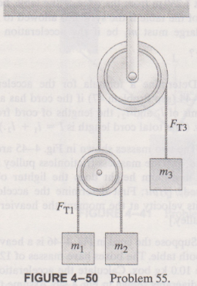
Solution:
We can set upward is the $+y$ direction, and we can get the free-body diagrams like Fig.Q-4-40.
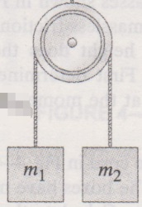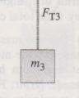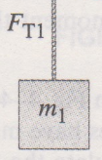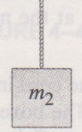
$$m_{3}g$$
$$m_{1}g$$
$$m_{2}g$$
$$F_{T1}$$
$$F_{T3}$$
$$(m_{1}+m_{2})g$$
(a)
(b)
(c)
(d)
Figure Q-4-40
Fig.Q-4-40 (a):
Set the acceleration of $m_{3}$ is $a_{3}$, so
$$a_{3}=\frac{F_{T3}-m_{3}g}{m_{3}} (1)$$
Fig.Q-4-40 (b):
Set the acceleration of $m_{1}$ is $a_{1}$, so
$$a_{1}=\frac{F_{T1}-m_{1}g}{m_{1}} (2)$$
Fig.Q-4-40 (c):
Set the acceleration of $m_{2}$ is $a_{2}$, so
$$a_{2}=\frac{F_{T1}-m_{2}g}{m_{2}} (3)$$
Fig.Q-4-40 (d):
Set the acceleration of the smaller Atwood machine is $a_{s}$, so
$$a_{s}=\frac{F_{T3}-(m_{1}+m_{2})g}{m_{1}+m_{2}} (4)$$
And
$$a_{3}=-a_{s} (5)$$
The relationship of $a_{1}$,$a_{2}$ and $a_{s}$ can see Fig.Q-4-41.(Set $a_{1}$ and $a_{s}$ is upward, the smaller pulley’s center is $s$)
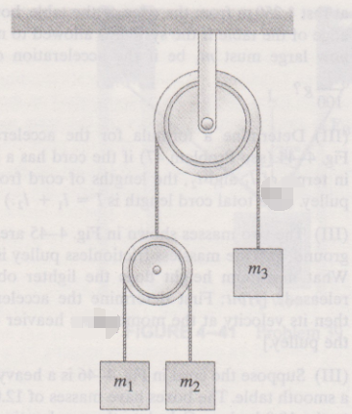
$$a_{1-c}$$
$$a_{2-c}$$
$$a_{s-c}$$
ceiling
s
Figure Q-4-41
$$a_{1}=a_{1-c},a_{2}=a_{2-c},a_{s}=a_{s-c}$$
$$∵a_{1-s}=a_{1-c}+a_{c-s}=a_{1-c}-a_{s-c}=a_{1}-a_{s}$$
$$∵a_{2-s}=a_{2-c}+a_{c-s}=a_{2-c}-a_{s-c}=a_{2}-a_{s}$$
$$∵a_{1-s}=-a_{2-s}$$
∴$a_{1}-a_{s}=-(a_{2}-a_{s}) (6)$
Now we can get the equation group:
$$\left\{\begin{aligned}&a_{3}=\frac{F_{T3}-m_{3}g}{m_{3}} \\ &a_{1}=\frac{F_{T1}-m_{1}g}{m_{1}} \\ &a_{2}=\frac{F_{T1}-m_{2}g}{m_{2}} \\ &a_{s}=\frac{F_{T3}-\left(m_{1}+m_{2}\right)g}{m_{1}+m_{2}} \\ &a_{3}=-a_{s} \\ &a_{1}-a_{s}=-(a_{2}-a_{s}) \end{aligned}\right.$$
Use MATLAB to solve it.
The code:
syms FT3 FT1 m1 m2 m3 g as a1 a2 a3
eq1 = a3 == (FT3-m3*g)/m3;
eq2 = a1 == (FT1-m1*g)/m1;
eq3 = a2 == (FT1-m2*g)/m2;
eq4 = as == (FT3-(m1+m2)*g)/(m1+m2);
eq5 = a3 == -as;
eq6 = a1-as == -(a2-as);
[a1,a2,a3,as,FT1,FT3] = solve([eq1,eq2,eq3,eq4,eq5,eq6],[a1,a2,a3,as,FT1,FT3])
And the answers are:
$a_{1}=$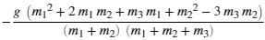
$a_{2}=$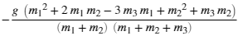
$a_{3}=$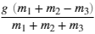
$F_{T1}=$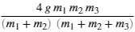
$F_{T3}=$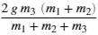

BUT THE ANSWERS of BOOK IS:


