Classical Argument Position Paper: Electric Airliners are Possible.
TCaddell
English 123
Embry-Riddle Aeronautical University

I would like to thank all the science-fiction and imagination of writers who inspire scientists in making the real devices such as: Rossum’s Universal Robots (1920) play written by Karel Capek; Star Trek (1966) presented communication devices now called cell phones; and deep sea exploration in the novel: 20,000 Leagues Under the Sea (1870) was only a dream by Jules Verne but now is very real. These and other science-fiction literature iarethe inspiration needed to move forward in technology.
Abstract
The claim that electric airliners operating using this apparatus treads on the science-fiction while based on real science. This paper covers new unrelated precursory technologies can come together to make a new type of airliner.

Electric Airliners are the Future of Travel
We need an environmentally safe way to travel over long distances other than current airliners. To build a new type of electric, large, flying wing, passenger, airliner to travel across the world, we have to forget most current airline standards. First, airliner should incorporate the advancements of wing technology are precursory to new aerodynamic aircraft. Next and throughout, the objection will be answered with the airliner running on electricity will be addressed. Next, the benefits of this “Electric Airliner (EA)” for the Earth and the passenger as opposed to combustion airliners listed throughout. Last the objection of airliner running on electricity will be addressed. This paper will demonstrate these unrelated technologies working in tandem to complement each other in creating a new cleaner and safer type of airliner.
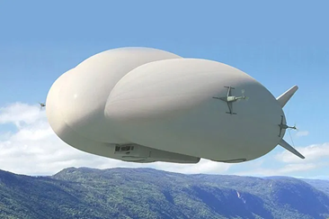
In order to run cleaner, advancements in recent wing technology must be utilized to mitigate turbulence and fly more efficient like birds do. By eliminating the vertical tail and introducing a wing that can twist to produce a good strong proverse yaw, like birds do to maneuver, an aircraft can increase its wing efficiency by 20 percent (Bowers, 2016). Proven to be more efficient, the shape and speed of the EA will be dictated by this type of wing technology. Another incorporation of technology such as, a hybrid solar airship produces lift from its buoyancy and its wing shape (Zhang et al., 2017). This wing shape allows a second means of lift achieving faster airspeeds for blimps (Matignon et al., 2019). Shrinking or raising the internal air pressure makes the blimp heavier than air thus converting lift from its buoyancy to its wing body. Next, if a blimp flies only by its wing shape, then it is a wing. The EA will need to shrink to a shape of a pancake-like flying wing the faster it travels.
(Matignon, 2019)
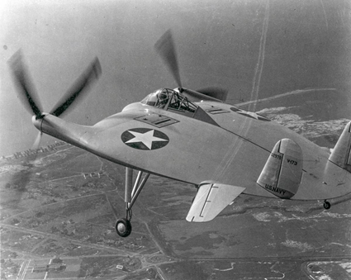
The V-173 or “Flying Pancake” has a very fuel-efficient wing design. Because of a bad gearbox and a vibration problem, it was discontinued but, not for its wing shape (Palmer, 2019). The scale-model Chance Vought V-173 on the left was demonstrated to be efficient at fast and slow speeds. Ignoring scale, the wing is ideal for cruising speed and the shape a hybrid airship could shrink down to while increasing airspeed. The flexible material of this hybrid airship or airliner (sure to be in a class of their own) will be able to utilize proverse yaw by adjusting the ballast pressure in the wingtips. In an emergency, unlike current airliners, the multi-chambered EA can inflate to minimize damages with a crash-landing airspeed of 0.
(Palmer,2019)

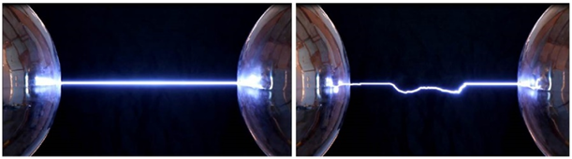
Objectively, one may ask, “How are these ‘EAs’ going to be solely powered by electricity? And doesn’t the batteries weigh too much for making EAs unfeasible?” To agree, only an external power supply could power the EA’s electric engine. Advancements in technology have shown, replacing hydro-mechanical systems with electrical drives in the form of individual actuators at each flap surface can provide greater functionality and eliminate the need for centralized hydraulic pumps (Cao, 2012). As a rebuttal to the battery problem, exclude the battery and the fuel weight, an airliner could be up to 40% more efficient (Robin, 2020). To recap, using both newer wing technology and supplying fuel externally an airliner can run up to 60% more efficient unlike the airliners of today. Second, by introducing a longitudinally elongated electromagnetic field to surround the airliner by can provide some of the EA’s needed electricity. The plane acts as a transformer to absorb the navigated voltage from the electromagnetic (EM) field that surrounds high-voltage wires, similar to fast wireless charging, (Zhang et al., 2019). In this case, the EM field is modified to have a much larger circumference. In addition to solar and navigated voltage supplied electricity, the high-voltage electromagnetic (EM) field conditions the space between the plane and rail. A strong EM field allows a lower-powered laser, emitted from the EA, to ionize a conduit for transferring electricity through the air called “laser filamentated electrical discharge” to the rail providing the remainder of electricity for the EA in flight. Below is an image of a completely guided discharge and an image of a partially guided discharge. The gap is 37.3cm and the sphere voltages are 186kV and -186kV respectively (Rastegari, 2016). Electric technology naturally produces ozone as a byproduct and helps in restoring the Ozone Layer. “These works have mainly been motivated by triggering of lightning from storm clouds and to transport electric charges to a specific position (Théberge et al., 2017).” These technologies altogether can transfer electricity efficiently over large air gaps possible thus, making the safest if not most efficient electric airliners plausible.
(Rastegari, 2016)
Smaller electric planes do exist, “powerlines with strong EM fields can power sail drones in flight,” lightning can be redirected with lasers, and wings can come in any shape or size to meet any purpose. We have the technology to build a hybrid electromagnetic assisted laser filamentated and navigated airliner; they should come together and upscale. Electric engines are sustainably efficient and help restore the Ozone layer. Therefore, it is not a matter of “if” electric airliners will be possible but, “when” and “how” they will fly.

References
Caddell, T. (2017, January 16). Can high voltage power lines EM provide power for drones? Electronics Stackexchange. https://robotics.stackexchange.com/questions/11449/can-high-voltage-power-lines-provide-a-super-highway-for-drones https://electronics.stackexchange.com/questions/280558/can-high-voltage-power-lines-em-provide-power-for-drones
Cao, W., Mecrow, B. C., Atkinson, G. J., Bennett, J. W., & Atkinson, D. J. (2012). Overview of electric motor technologies used for more electric aircraft (MEA). IEEE Transactions on Industrial Electronics, 59(9), 3523-3531. doi:10.1109/TIE.2011.2165453
Matignon L. (2019). Future of dirigible balloons. Space legal issues. https://www.spacelegalissues.com/the-future-of-dirigible-balloons
Polmar, N. (2019). Ships and aircraft of the U.S. Fleet. Naval History Magazine. https://www.usni.org/magazines/naval-history-magazine/2019/june/pancake-didnt-fly
Rastegari, A., Schubert, E., Feng, C., Mongin, D., Kamer, B., Kasparian, J., . . . Diels, J. (2016). Beam control through nonlinear propagation in air and laser induced discharges. SPIE Digital Library, 9727 97271H-97271H-12. doi:10.1117/12.2213650
Robin B. (2020). How efficient would an airliner be if it did not have to carry its own fuel? Aviation Stack Exchange. https://aviation.stackexchange.com/questions/74494/how-efficient-would-an-airliner-be-if-it-did-not-have-to-carry-its-own-fuel
Théberge, F., Daigle, J., Kieffer, J., Vidal, F., & Châteauneuf, M. (2017). Laser-guided energetic discharges over large air gaps by electric-field enhanced plasma filaments. Scientific Reports, 7(1), 40063. doi:10.1038/srep40063
Zhang, L., Lv, M., Meng, J., & Du, H. (2017). Optimization of solar-powered hybrid airship conceptual design. Aerospace Science and Technology, 65, 54-61. doi:10.1016/j.ast.2017.02.016
Zhang, Y., Yan, Z., Kan, T., & Mi, C. (2019). Interoperability study of fast wireless charging and normal wireless charging of electric vehicles with a shared receiver. IET Power Electronics, 12(10), 2551-2558. doi:10.1049/iet-pel.2018.6080

