Direct download of a rather comprehensive utility set:
https://www.hirensbootcd.org/files/HBCD_PE_x64.iso
ISO SHA1​ | 6CBC2FFFB4D0563852A43F7E16A67581BD6BD809​
Rufus USB Boot Utility:
https://rufus.ie/
https://sourceforge.net/projects/rufus.mirror/
When you have used Rufus and the Hirens .iso file to write a bootable Hirens USB device (you could also burn the .iso file to a DVD), you can boot from it (you may need to go into setup or a boot options menu to do this), and go into the password menu and select the NT password utility. Please note that this utility will not try to retrieve any existing plaintext password from an encrypted hash, but instead will simply write a new password or render the ID usable without a password.

After copying any data that you care about from the USB device, plug it in and launch Rufus. You should get a screen like this (with your current version number in the title Bar):
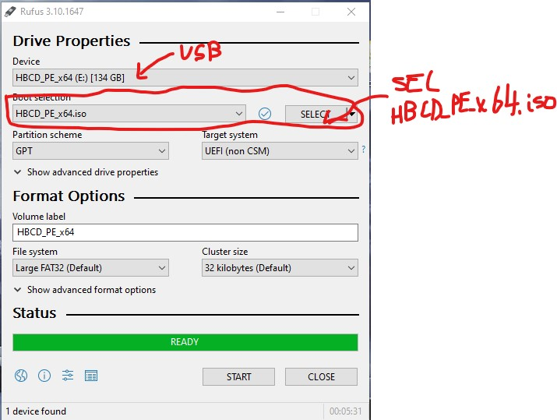
Make sure that the Device field shows your intended USB device.
At the Boot selection field, click on the down arrow and navigate to your Hirens .iso file. Leave the other fields at their defaults. When the Ready bar shows green and the Start button is not greyed out, that means that Rufus has found the device and the .iso file.
Hit the Start button.
If you get a warning about overwriting or destroying data it should refer only to the device listed in the Device field.
Assuming that you're sure that the correct USB device is selected, go ahead and ok the overwrite.
Rufus will announce it when the process is complete. Close Rufus, plug the USB into the machine that has the password problem,
- Power up, hit ESC and will get into Power-On Authentication. Highlight BIOS Adm. ENTER
- Type Rooster1 then ENTER and hit ECS right away. This will show up. 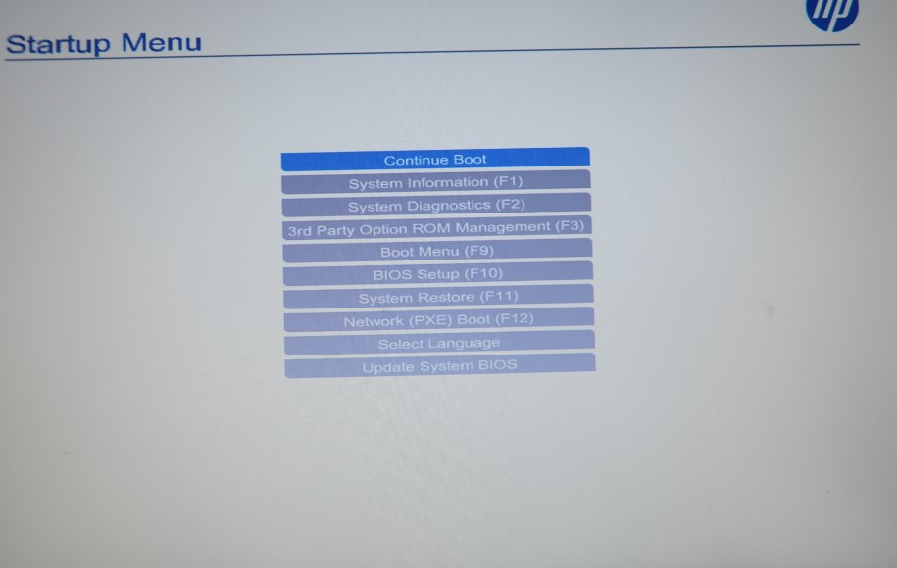
- Hit F9 to Boot Menu
- Click ADVANCED on the top right and choose BOOT OPTION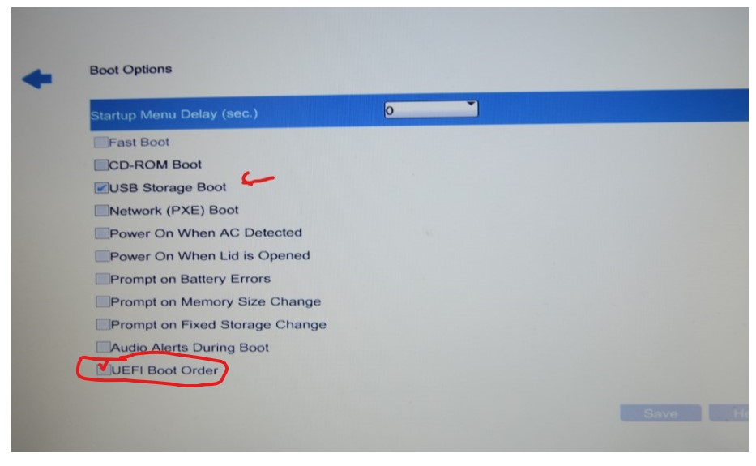
- Click Save and Exit, it will restart into the Hirens desktop.
- Click UTILITIES->Security->Passwords and get into this screen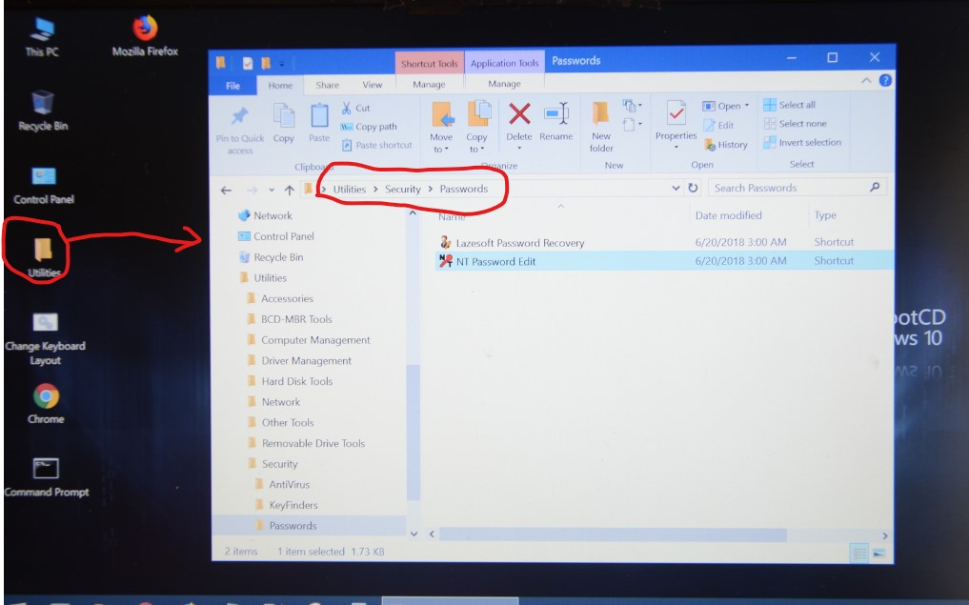
- Choose NT password Edit.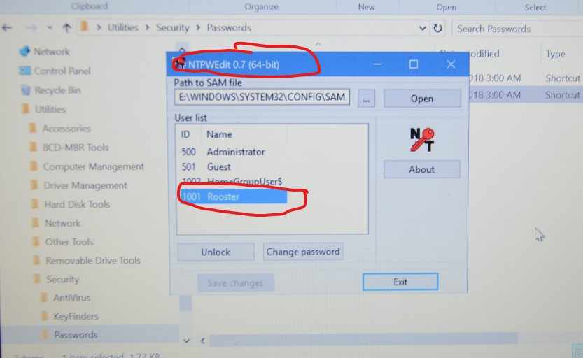
- Follow the instruction and type in the new password and retype, then click Save Changes
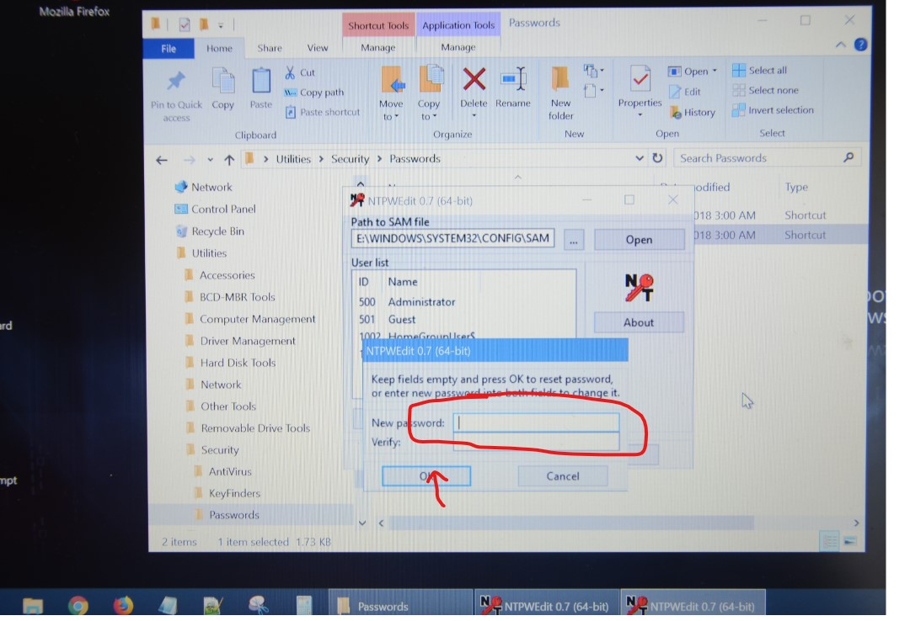
- Unplug the USD, turn off power and restart.

