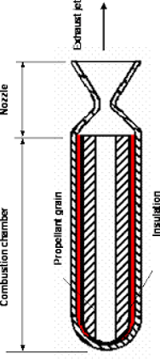

Can enough outward force be created through spinning onto the diagonal surface of the exit cone to significantly effect the overall thrust of the engine.

