Solenoid Computer Investigation Lab
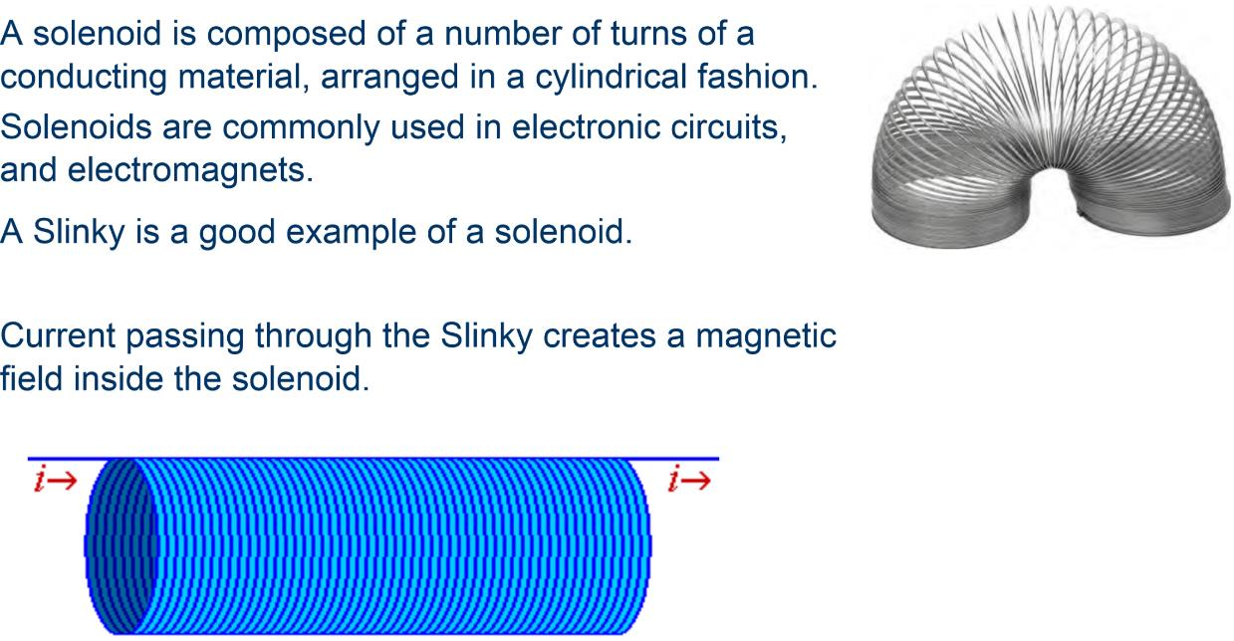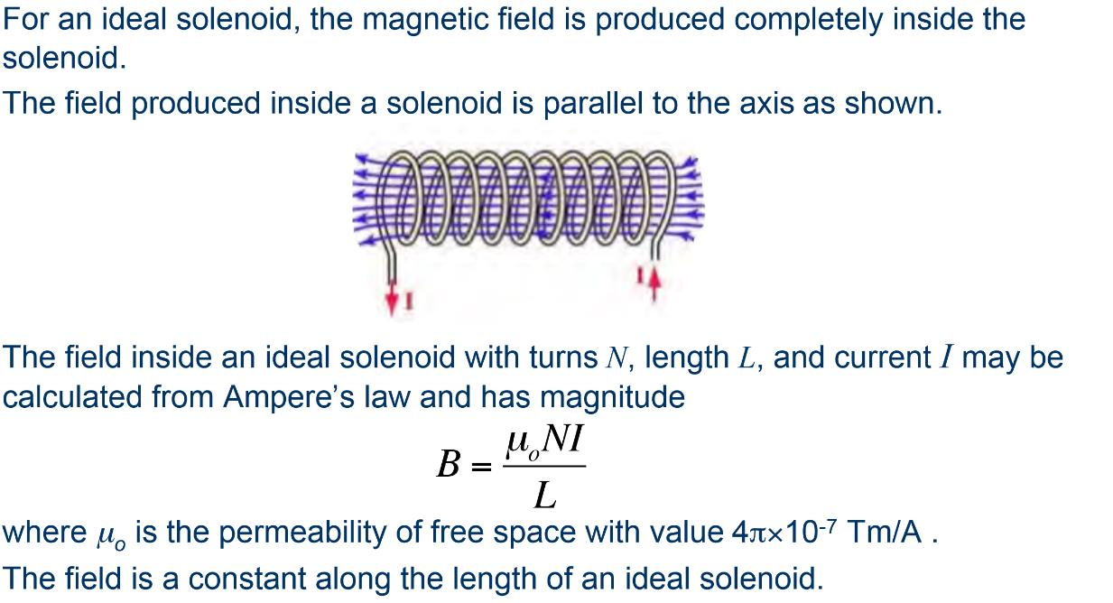

Question: How does the radius of the loops of a solenoid affect the magnetic field produced by the coil?
Hypothesis ________________________________________________________________________________________________________________________________________________________________
Materials:
Computer Applet: http://vnatsci.ltu.edu/s_schneider/physlets/main/bsolenoid.shtml
Write up a procedure
________________________________________________________________________________________________________________________________________________________________________________________________________________________________________________________________________________________________________________________________________________________________________________________________________________________________________________________________________________________________________________________________________________________________________________________________________________________________________________________________________________________________________

Conclusion: ________________________________________________________________________________________________________________________________________________________________

